Copyright 2025 | www.mihin.org | help@mihin.org



MIGateway®
User Guide

Version 19
August 4, 2026

Document History
Date | Version | Sections Revised | Description | Modifier
05/31/24 | 1 | All | Updated Content | T. Fite
7/23/24 | 2 | All | Update to incorporate all individual MIGateway User Guide Modules into one document and to update to reflect ITP. | M. Allen, T. Fite
11/15/24 | 3 | All | Edited for branding | E. Mata
12/4/24 | 4 | 3.4 | Format changed | E. Mata
12/10/24 | 5 | All | Editing | K.Lewis, S. Denhof
1/22/2025 | 5 | All | Editing and Formatting Updates | M. Allen
2/7/2025 | 5 | All | Editing | K. Lewis, S. Denhof
5/1/2025 | 6 | Section 3.1,3.4,3.6 and Appendix F | Updated screenshots of all LR sections and updated corresponding descriptions. Updated information on TOC viewer module. Updated email information and screenshots in section 3.1. Fixed page number issues. | M. Allen
7/2/2025 | 7 | Section 3.7 | Added section 3.7 Provider Results Viewer | M. Allen
7/24/2025 | 7 | Section 3.3 | Added ACRS® CareLink information into the Patient Viewer Module | M. Allen
9/25/2025 | 8 | Sections 3.1-3.4 | Updated screenshots to reflect UI adjustments, updated information regarding ACRS® CareLink Functionality. | M. Allen, B. Gokee
11/11/2025 | 8 | Section 3.3.2.2 | Added information about Show all ID, Address, and Phone number links. | M. Allen H. Burseth, B. Gokee
12/3/2025 | 9 | Section 3.6.1.12 and Section 3.6.2.2 | Updated Lab Results in the Longitudinal Record UI and UI description section and showed added section describing pdf export of lab results. | H. Burseth, A. Gregory, M. Allen
1/16/2026 | 10 | Section 3.6.2.2 | Added Diagnostic Imaging as an applicable section for the view and download instructions | H. Burseth
1/23/2026 | 11 | Section 3.3 | Updated to include screenshots and descriptions for using Patient Search to find patients in ACRS® instead of the eMPI. | H. Burseth
2/11/2026 | 12 | Section 3.5.2 | Added this new section for Diretto Directory. | C. Walterman
2/20/2026 | 13 | Section 3.5.1, Section 3.6.1.3 | 3.5.1: Updated Diretto Inbox interface section  3.6.1.3: Updated the Medication Order and Request screenshot and descriptions | C. Walterman,  H. Burseth
3/13/26 | 14&15 | All | Updated figure #s, table of contents, headers, etc. | D. Yun/K. Lewis
3/26/26 | 16 | Section 3.1.2.3; Section 3.4.1.1 | 3.1.2.3: Updated Delivery File error screenshot  3.4.1.1: Updated ADT Filter screenshot and UI Filter Elements table | B. Gokee/H. Burseth
5/28/26 | 17 | Appendix F | Added email example related to Invalid File Type submitted via SFTP | B. Gokee
06/11/26 | 18 | Section 3.3.2.2; Section 3.6.1.15 | Updated screenshot for “Documents” tab; added bullet points to Vital Signs table | B. Gokee
07/23/26 | 19 | Section 2.3.1 | Updated Figure 11 for Support Module to show updated affected modules | B. Gokee

Table of Contents
Document History 1
1. Introduction 5
1.1 Purpose 5
1.2 Functionality 5
1.3 Data Flow 6
2. Login and Support 6
2.1 Accessing MIGateway® 6
2.1.1 Initial Login 6
2.1.2 Forgot Password 10
2.1.3 Password Expiration 10
2.2 Single Sign-On (SSO) 11
2.3 Requesting Support 11
2.3.1 Support Module 11
2.3.2 Additional Support Information 12
3. Modules 13
3.1 File Submission 13
3.1.1 File Submission UI Elements 13
3.1.2 Getting Started with File Submission 18
3.2 Manage ACRS® 24
3.2.1 Manage ACRS® UI Elements 25
3.2.2 Working with ACRS® Populations 27
3.3 Patient Viewer 33
3.3.1 Patient Viewer User Interface (UI) Elements and Views 34
3.3.2 Using the Patient Viewer Module 40
3.4 Transitions of Care (TOC) Viewer 50
3.4.1 TOC Viewer UI Elements 50
3.4.2 Working with Transitions of Care Messages 55
3.4.3 Reporting with TOC Viewer 59
3.5 Diretto® 61
3.5.1 Diretto® Interface 62
3.5.2 Diretto® Directory Interface 65
3.6 Longitudinal Patient Record 69
3.6.1 Longitudinal Record UI Elements 69
3.6.2 Getting Started with Longitudinal Patient Record 84
3.7 Provider Results Viewer 87
3.7.1 Provider Results Viewer UI Elements 88
3.7.2 Using the Provider Results Viewer 93
4. Appendices 95
4.1 Appendix A - Allowing Third-Party Cookies 95
4.2 Appendix B - MIGateway® Applications with Cut-Off Drop-Down View 96
4.3 Appendix C - Service Communication 96
4.4 Appendix D – Moving Away from Support of Internet Explorer (IE): 97
4.5 Appendix E – Wildcard Searches 97
4.6 Appendix F – Validation Email Examples 97
4.7 Appendix G – C-CDA Documents 101
4.8 Appendix H – Expiration Notice Email 98
4.9 Appendix I – Troubleshooting Optional Fields when Adding a new Patient/Relationship 98
5. Production Support 100
6. Acronyms and Abbreviations Guide 101
7. Definitions 102

1. Introduction

1.1 Purpose
MIGateway® gives providers and managing organizations a single, consistent, interoperable solution for coordinating patient care.
The Medical Information Gateway (MIGateway®) is a service that centralizes Michigan Health Information Network Shared Services’ (MiHIN) Use Case applications to help healthcare professionals find, view, use, and exchange health information for their patients.
Many providers have adopted Electronic Health Records (EHRs) to digitize and exchange health information, but the lack of interoperability among EHR vendors still impedes the effective exchange of electronic health information.
MIGateway solves this challenge with an easy-to-use interface that offers a single point of entry to access a host of shared services available in the State of Michigan for practices, managing organizations, and other care coordination organizations.

1.2 Functionality
MIGateway creates opportunities to make information exchanged through Michigan’s statewide network usable and valuable. MIGateway allows users to:
- View other members of a patient’s care team, manage shared information for their patients, and view treatment information in the form of transitions of care (TOC) messages.
- Upload Active Care Relationship Service® (ACRS®) files.
- MIGateway provides tools to view and work with several different message types and data, including:
- Admission, Discharge, and Transfer (ADT) messages with any message enrichments
- Documents conforming to clinical document architecture standards including Continuity of Care Documents (CCDs)

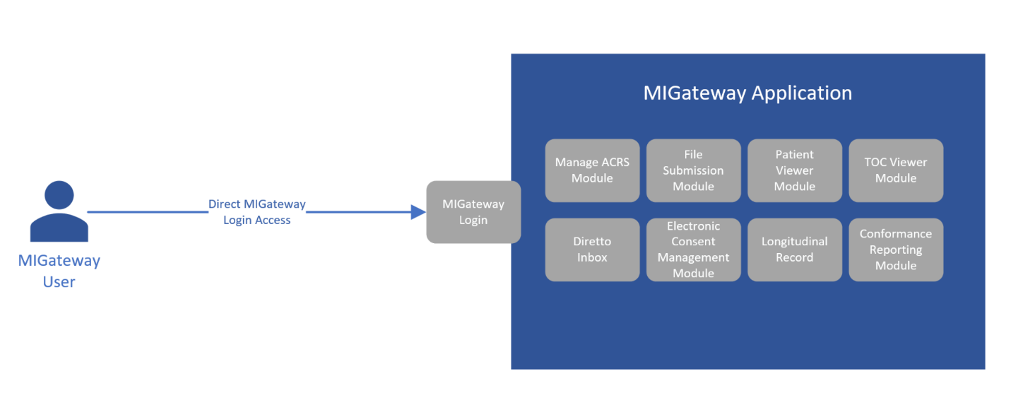
1.3 Data Flow
Figure 1. MIGateway Data Flow
Figure 1 shows the data flow a MIGateway User would follow. The full application summary is available online at: https://mihin.org/migateway/ . For additional information, visit www.mihin.org/requesthelp.

2. Login and Support
The following sections describe the user interfaces and basic processes performed in each module. There are also processes that are either agnostic to any of the modules, or which use a combination of modules.

2.1 Accessing MIGateway

2.1.1 Initial Login
A welcome email from MiHIN will be delivered to the registered email address to set up an account once a completed request form has been received and processed.
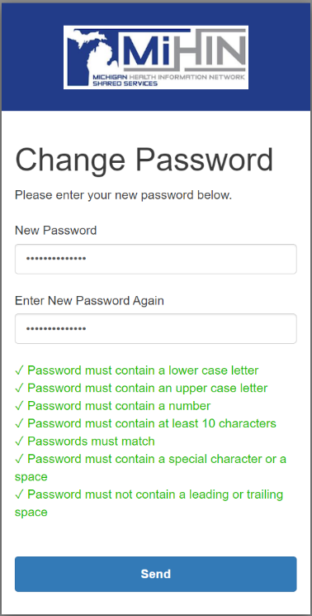
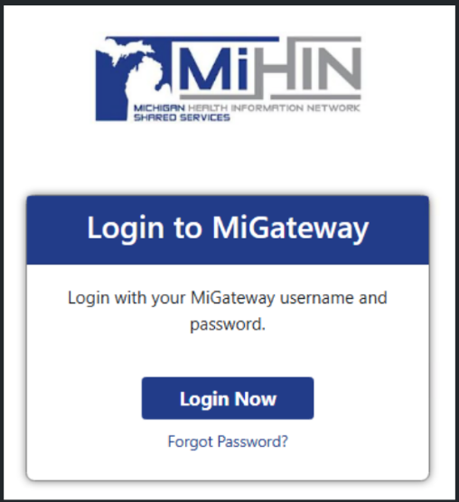
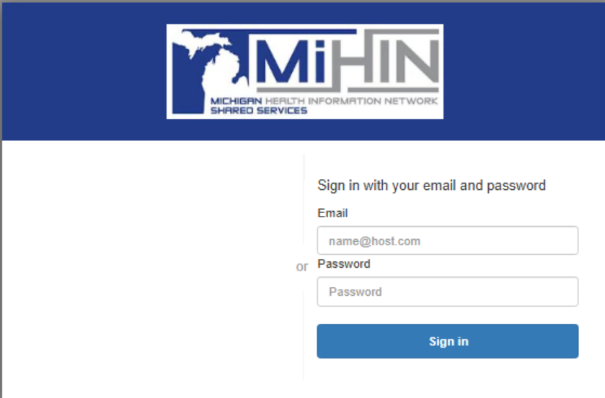
- Click the link in the email to begin registering a MIGateway account. On the MIGateway login screen as shown in Figure 2, select “Login Now”. Once on the Email and Password screen, as shown in Figure 3, enter the username and temporary password provided in the welcome email and click “Sign in”.
Figure 2. Initial Login Screen
Figure 3. Email and Password Login Screen
Figure 4. MIGateway® Set Password
- A password reset will be required with requirements displayed as shown in Figure 4.
- Create a password and click ‘Send.’
- After creating your new password, you will be required to set up multi-factor authentication (MFA). Follow the instructions, as shown in Figure 5.
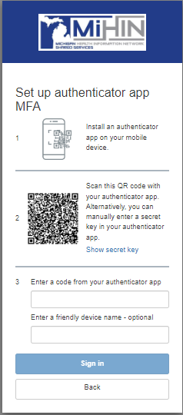
Figure 6. MIGateway Account Creation Multi-Factor Authentication

- Enter the authentication code from your choice of authenticator applications and click “Sign in” as shown in Figure 5.
- After establishing multi-factor authentication, you will automatically be asked to sign in again with your new password and enter the code from MiHIN’s passcode app as shown in Figures 6 and 7.
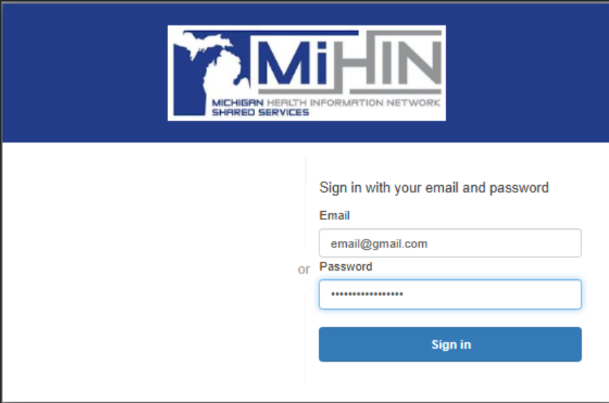
Figure 6. MIGateway® Login Page
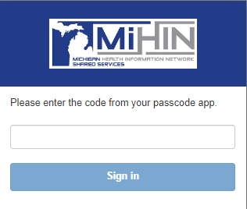
Figure 7. MIGateway Login Page - Submit Authentication Code

Please Note: MiHIN’s MIGateway application no longer supports the use of Internet Explorer. For more information and recommended browsers, please see Appendix E.

2.1.2 Forgot Password
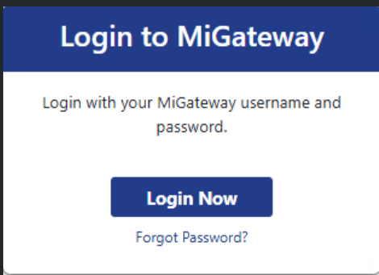
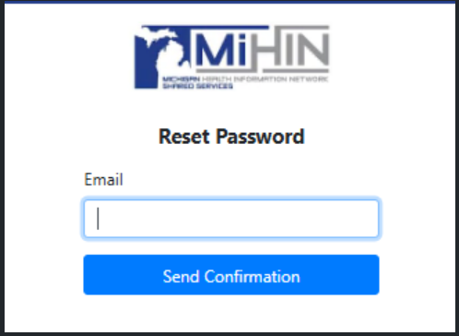
If a new password is needed, select ‘Forgot password?’ as shown in Figure 8. Enter your email address to receive the reset instructions as shown in Figure 9. If difficulty occurs with password reset, please contact help@mihin.org.
Figure 9. MIGateway Password Reset
Figure 8. MIGateway Forgot Password Link

2.1.3 Password Expiration
- MIGateway passwords are valid for 90 days from the date the account was created, with expiration reminders sent at 75, 85 and 90 days from account creation. An example of this notice can be found in Appendix H
- After 90 days the MIGateway account will be disabled until the account password is reset
  - The user must submit a request to help@mihin.org requesting their MIGateway account be re-enabled after the 90 days of inactivity.
- Once the account is re-enabled, an email will be sent to the email address associated with the account with instructions on how to reset the account password.
- Once the account password has been reset, the new password age will be set back to zero days.

2.2 Single Sign-On (SSO)
In addition to signing into MIGateway via the process outlined in Section 2.1, MiHIN allows for the configuration and use of SAML based single sign-on (SSO) access to configured modules within the application. Single sign-on allows MIGateway users from an organization to utilize one point of access which can be configured to use the provisioned modules via an interface or link within an organization’s EMR.
All modules within MIGateway can be accessed via SSO. During onboarding and the account setup process, an organization implementing MIGateway access via SSO will have identified which users should have access to which modules. For more details on this process and procedure, please refer to the MIGateway Integration Guide and the MIGateway Onboarding Form which should have been distributed during onboarding.
Regardless of how module access is provisioned with SSO, once accessed, this should have no impact on the function of each individual module. Once logged in, all modules should function as described in their associated user guide sections located throughout this document.

2.3 Requesting Support

2.3.1 Support Module
The Support module allows users to submit support tickets directly from MIGateway to MiHIN’s Help Desk. To access the module, click on the ‘Support’ tab in the navigation bar as shown in Figure 10.

Figure 10. Support Tab in the Navigation Bar
Once on the Support page, complete the required fields on the webform as shown in Figure 11. If a support request involves PHI, click the ‘Additional PHI Needed?’ checkbox under the description field.
**Please, do not submit any PHI through the Support module or the MiHIN ticketing system directly. If PHI needs to be exchanged, MiHIN will use secure methods for its exchange.**
Once the support ticket is ready for submission and all required fields have been filled out, click ‘Submit Message.’ MiHIN’s Help Desk will respond via email to the support ticket to the email address used for initial MIGateway login.
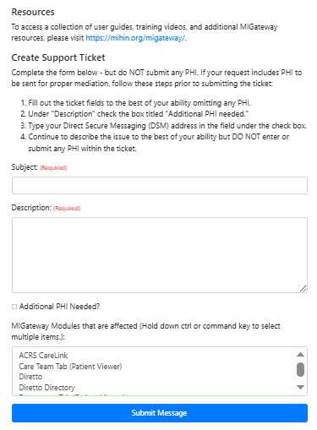
Figure 11. Support Ticket Page

2.3.2 Additional Support Information
Additional information on MIGateway can be found online at https://mihin.org/migateway

For support please contact:
MiHIN Help Desk
844-454-2443
help@mihin.org
MiHIN Help Desk Portal (https://mihinhelp.refined.site/portal/50)

3. Modules
The MIGateway application is composed of several modules. Common tasks managed through MIGateway often utilize multiple modules working together.
This section is intended to give a foundational knowledge for each module.

3.1 File Submission
The File Submission module allows organizations to submit their ACRS® file via MIGateway® and receive processing and feedback in return.
Additionally, through the File Submission module, an organization can see information relevant to their submitted ACRS® file including:
- Time/Date of Submission
- Status of File
- ACRS® file name for both delivery and attribution files
- Transaction IDs for all submitted files
- Status Message indicating the outcome of the submission and whether there were any errors found.

3.1.1 File Submission UI Elements
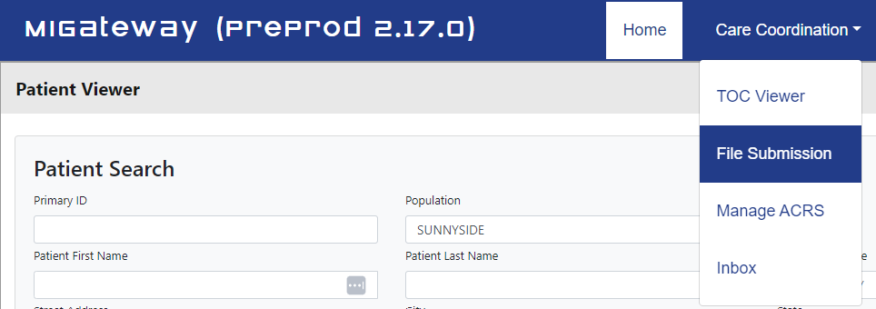
The File Submission module can be accessed by navigating to the Care Coordination drop-down menu and selecting the File Submission option as shown in Figure 12.
Figure 12. File Submission Menu Location
The File Submission module has two tabs that users can select from depending on what tasks they are attempting to complete. These are as follows:

3.1.1.1 File Submission Tab
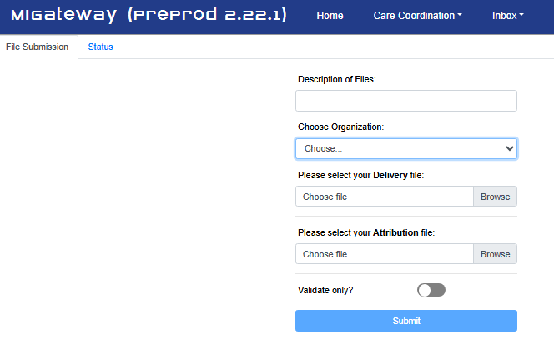
This tab has the primary interface used for the submission of ACRS® files. Its UI elements are illustrated in Figure 13:
Figure 13. File Submission Tab Layout
This form has several elements that allow a user to customize the ACRS® file submission process. A breakdown of these elements is illustrated in Figures 14 and 15.

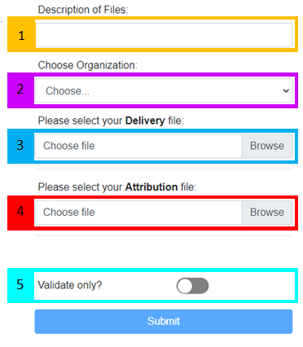
Figure 14. File Submission UI Elements
1 | Description of Files: Text field used to provide a description of the files being submitted, including type of files, which facility they are for, and other identifying information. Information is at the submitting user’s discretion. No PHI should be used in this field.
2 | Choose Organization: Drop-down list of applicable organization ACRS® Population’s names.
3 | Please select your Delivery file: Field that allows users to browse available drives to find and select the Delivery file to submit.
4 | Please select your Attribution file: Field that allows users to browse available drives to find and select the Attribution file to submit.
5 | Validate only?: Clicking the “Validate Only?” toggle will run validation on the uploaded files without submitting and loading the files afterward. Both validation and cross validation errors will be returned.
Figure 15. File Submission UI Element Description

3.1.1.2 Status Tab
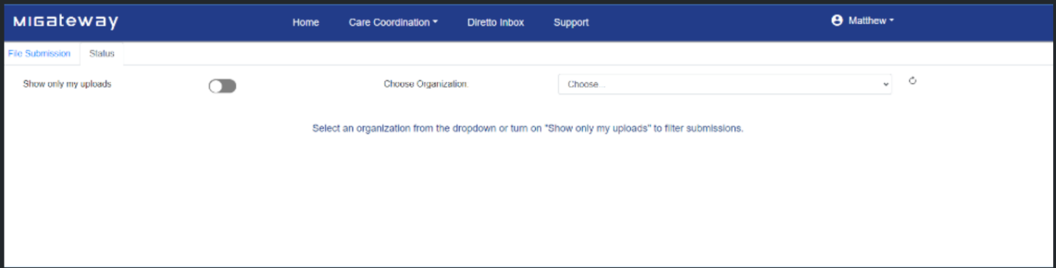
The Status tab provides search tools that allow a user to check on the status of submitted ACRS® attribution and delivery files. Its UI elements are illustrated in Figure 16.
Figure 16. Status Tab Layout
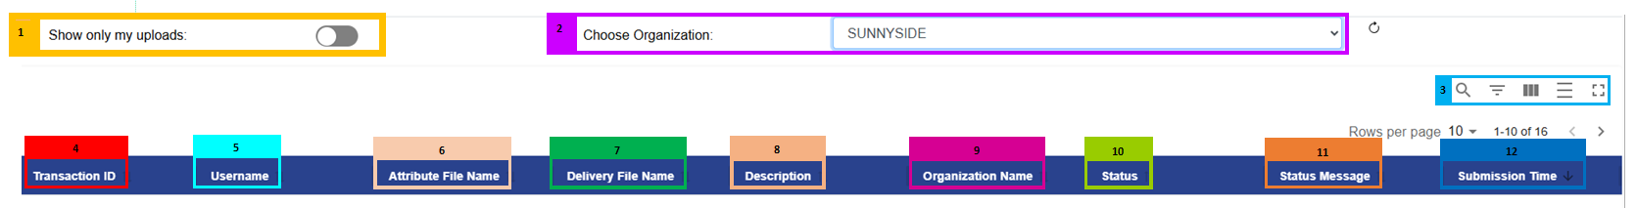
This UI has elements designed to help search for the status on select ACRS® files, and headers which display status information on those files as shown in Figures 17 and 18.
Figure 17. Status Tab UI Elements

1 | Show only my uploads: Clicking this toggle will filter file submission transactions to those submitted by the user.
2 | Choose Organization: Drop-down list of organization ACRS® Population names.
3 | View Toggles: Each icon represents an option to change the view of the UI interface including:      Search – Toggle to show or hide the search field to search specific criteria within the displayed results  Show/Hide Filters – Toggle to show or hide the filter fields for each column    Show/Hide Columns – Brings up a menu of all columns, with an option to keep them visible or hide them in the view      Toggle Density – Toggles how much space is left between each line of the view. Clicking this multiple times will change the spacing with each click  Toggle Full Screen – Toggles between only showing the status results on the page and showing the entire page
4 | Transaction ID: Shows the unique ID attributed to a submitted file and can be used to identify a specific submission status.
5 | Username: Lists the username of the user that submitted a specific Attribution and/or Delivery file.
6 | Attribution File Name: Lists the full name of a submitted Attribution file associated with a specific Transaction ID.  - Attribution Files that are loaded together with a Delivery file will be displayed with that corresponding Delivery file
7 | Delivery File Name: Lists the full name of a submitted Delivery file associated with a specific Transaction ID  - Delivery files that are loaded together with an Attribution file will be displayed with that corresponding Attribution file.
8 | Description: The Description of Files entered during file upload via File Submission. If the file was submitted via SFTP, the description will be automatically populated with “SFTP Submission.”
9 | Organization Name: Organization ACRS® Population name that the submitted files are associated with
10 | Status: Status of the submitted Attribution and Delivery files  - “Partial Loading” Status indicates when a file is submitted for partial loading after failing to validate in a previous submission  - “Validating” Status indicates the files are in the process of being validated  - “Incorrect File” Status could indicate either the file was submitted with formatting issues (like the file was not CSV formatted); or headers are missing or in the wrong order.  - “Error” Status indicates that a problem occurred during validation or loading. For assistance, please place a ticket to help@mihin.org.  - “Invalid” Status indicates that something about either the attribution or delivery file did not meet file specifications and could not be processed  - “Loaded” status indicates that the file has at least partially passed validation and has been loaded for use.  - “Valid” Status indicates that the selected files were valid, but did not proceed with loading because the “Validate Only?” toggle was selected when submitting the files.  - “Loading” Status indicates the files are in the process of loading
11 | Status Message: Lists additional information on the status of a file including the following information:  - An internal error occurred. Please contact the Help Desk at help@mihin.org for validation errors and reference the transaction ID #####. – Indicates an error has occurred with process an ACRS® file and is usually associated with the “Error” status.  - Cross-Validation is not valid. Click here for more information – Indicates that there are discrepancies between the submitted Attribution and Delivery file; and provides a link that lists said errors for correction. Usually associated with the “Invalid” status.  - Incorrect Delivery/Attribution file type or format submitted. – Message that occurs with the “Incorrect File” Status and indicates that while the overall CSV format was correct, the Delivery or Attribution file that was submitted had non-valid CSV headers.  - SFTP Submission was too invalid to continue – Message occurs with the “Invalid” status and occurs when a threshold for percentage of rows is invalid for SFTP submissions.  - Delivery/Attribution/Cross Validation are invalid – Message that occurs with the “Invalid” Status and indicates which validations failed when both a Delivery and Attribution file are submitted. May be any combination of the three depending on the validation issues that occurred.  - Attribution, Delivery and Cross Validation are valid – Message that occurs with the “Valid” or “Loading” status and indicates that all files, and their cross validation are valid.  - All valid, files loaded – Message that occurs with the “Loaded” status and indicates that all files were deemed valid and were loaded
12 | Submission Time: Lists the timestamp of the submission in the following format:  - YYYY-MM-DD-HH:MM: SS
Figure 18. Status Tab UI Element Descriptions

3.1.2 Getting Started with File Submission

3.1.2.1 Submitting an ACRS® Attribution and/or Delivery File
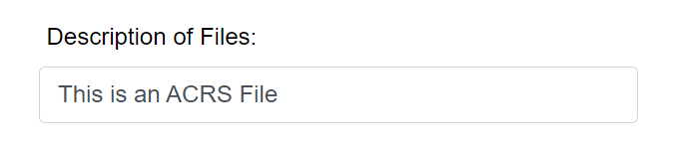
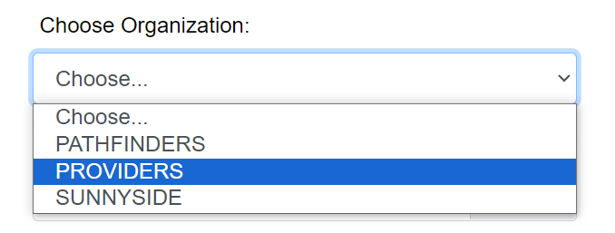
Organizations wishing to submit their ACRS® file will first navigate to the File Submission module described in the previous sections. In the File Submission form, organizations can enter in a description of the file being submitted (optional) and choose their organization from the drop-down menu as illustrated in Figure 19.
Figure 19. Selecting ACRS® File Description and Organization
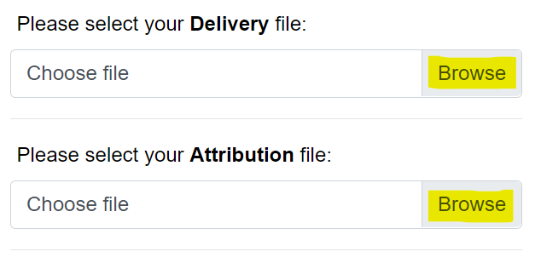
The list of names displayed in this drop-down menu is determined by the ACRS® Population(s) and organization information provided in the MIGateway® Onboarding Form. Once these fields have been completed, the organization will select the Attribution and/or Delivery file to be submitted by clicking the “Browse” button for each entry as shown in Figure 20.
Figure 20. ACRS® Attribution and Delivery File Selection Fields
Please note: Attribution and Delivery files can be submitted independently of each other if this has been configured during MIGateway® setup. If this is configured, completion of both fields will not be required.


Please note: the “Validate only?” toggle is off by default and will only be selected when an organization is looking to evaluate to see if their file is valid without submission as shown in Figures 21 and 22.
Figure 21. Off Position
Figure 22. On Position
If the user has been configured to submit the Attribution and Delivery files independently, a pop-up message will appear after submitting either file without the other, as shown in Figure 23.
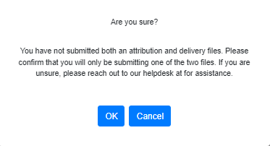
Figure 23. Single File Submission Confirmation Screen
For more information on creating Attribution and Delivery files that meet specifications, refer to the ACRS® Implementation Guide.

3.1.2.2 View the Status of Uploads
After a file has been submitted, the user can check the status of the file by navigating to the “Status” tab described in section 3.1.1.2. On this screen, the user will select the organization they would like to see file status for as shown in Figure 24.
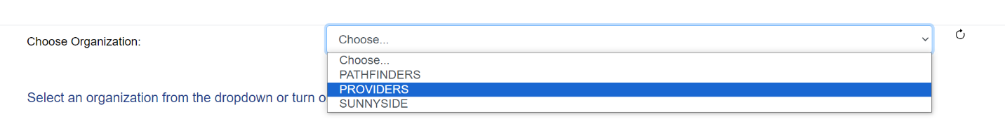
Figure 24. Organization Drop-Down
Additionally, if the user would like to only see the files they uploaded, they may activate the “Show only my uploads” toggle as shown in Figure 25.

Figure 25. “Show Only My Uploads" Toggle
Once selected, a list of all ACRS® file submissions associated with the organization will be displayed, listing all the information described in section 3.1.1.2 .Users should take note of the following information:
- Transaction ID – This is a generated ID associated with the submission. This information creates a unique identifier that can be used by internal MiHIN staff to identify and troubleshoot issues with files. Users should always try to provide this ID when reporting issues or asking questions about a particular submission
- Status – The status of a submission will let the user know what action, if any, is required for their submitted files. For a full list of potential statuses, please refer to section 3.1.1.2.
- Status Message – The Status Message provides further information on the statuses described previously. For a full list of potential status messages, please refer to section 3.1.1.2
- Submission Time – This lists the time and date of the submission. This is useful when reporting issues or trying to identify one file of many that an organization may have submitted. When sending help requests, this information should be provided along with the transaction ID to aid in troubleshooting

3.1.2.3 Address Upload Error/Invalid Messages
For files that have failed validation, a review will be required to address the issues indicated in the “Status Message” section before the files are able to be successfully loaded and used. For files that have the “Invalid” status, a link will be provided that identifies the issues behind the status. The errors are divided into three categories:
- Attribution File Validation Errors
- Delivery File Validation Errors
- Cross-Validation Errors
For each type of error, the page will indicate a file row and the related column that needs attention, and an error message will be provided as shown in Figures 26-28.
- Attribution File Errors
Lists each row or group of rows and columns where validation errors occurred along with the specific error(s).
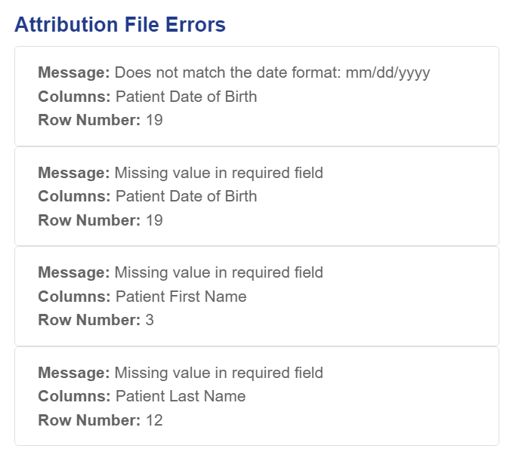
- Delivery File Errors
Figure 26. Attribution File Error Example
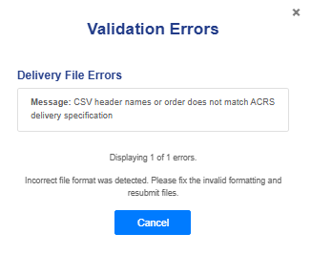
Lists each row, column, and/or headers where validation errors or formatting issues occurred, along with the specific error.
Figure 27. Delivery File Error Example

- Cross-Validation Errors
Cross-Validation Errors will be listed so the submitter can make corrections to prevent message routing or delivery issues in the future. It should be
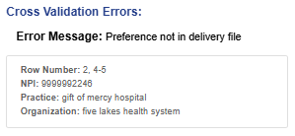
noted that Cross Validation Errors will only represent valid rows. If there are cross-invalid rows, they will be represented in groups, as shown in Figure 28.
Figure 28. Cross-Validation Error Example

3.1.2.4 Working with Files with Errors
The File Submission module allows the submission of files that contain validation errors. This function will remove all rows containing validation errors within either the attribution or delivery file. This can be done by clicking the “Submit” button on the validation errors pop-up window, as shown in Figure 29.
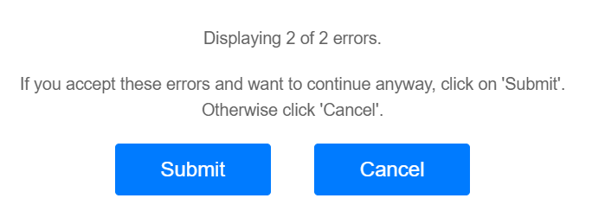
Figure 29. File Submission Invalid Rows Submission Screen
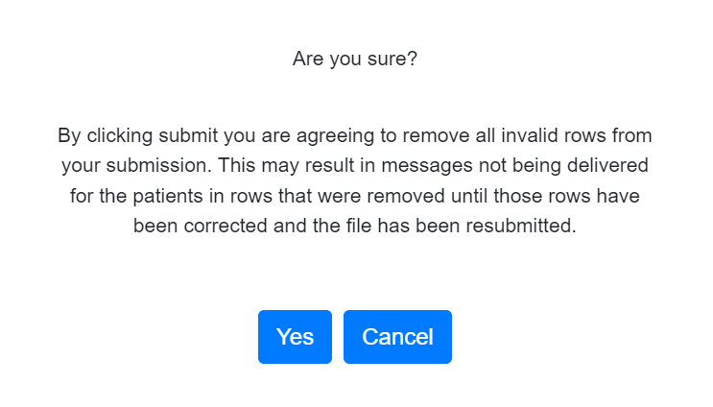
After clicking the “Submit” button, another pop-up window will appear asking for confirmation as shown in Figure 30. Clicking “Yes” will load the file and remove the rows with validation errors in them but will also mean that messages will not be routed based on those deleted rows.
Figure 30. File Submission with Invalid Row Confirmation
Once the files have been submitted, email messages will be generated and sent to the email address associated with the submission. This will either be the MIGateway® user account email or the one associated with the SFTP User Account through which the files were uploaded.
Emails will always be delivered when files go through at least one of the following, regardless of success or error status:
- Attribution Validation
- Delivery Validation
- Cross Validation
In situations where a file is found to be invalid, a file will be attached to the email with explanations detailing the source of the error. This will be the same file that users can see when reviewing file submissions in the “Status” tab, illustrated earlier in this section. For examples of emails that can be sent for given validation scenarios, please refer to Appendix 4.6.

3.2 Manage ACRS®
Manage ACRS® allows direct access to ACRS® populations within MIGateway®, offering the ability to search patient populations using represented filters or to add or modify active care relationships on demand. The features included with Manage ACRS® provide the following views:
- Hierarchy of active care relationships within a network
- Access to all active care relationships within personal hierarchy
- Active care relationships associated with a specific practice
- Active care relationships with a specific provider
- Patient care team

3.2.1 Manage ACRS® UI Elements
Manage ACRS® can be accessed by navigating to the Care Coordination drop-down menu at the top of MIGateway® and clicking “Manage ACRS®” as shown in Figure 31.
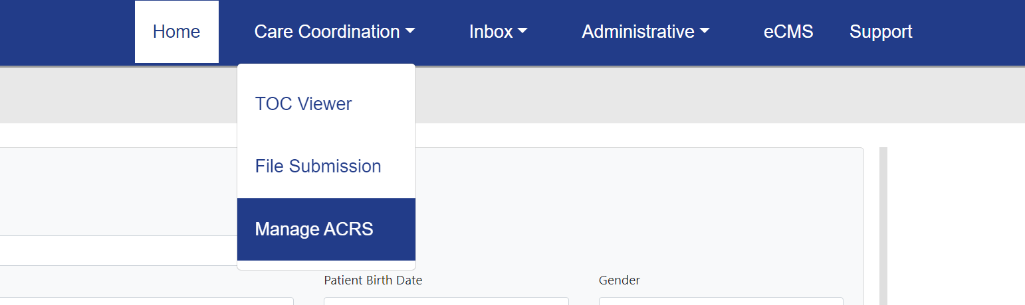
Figure 31. Manage ACRS® Menu Location
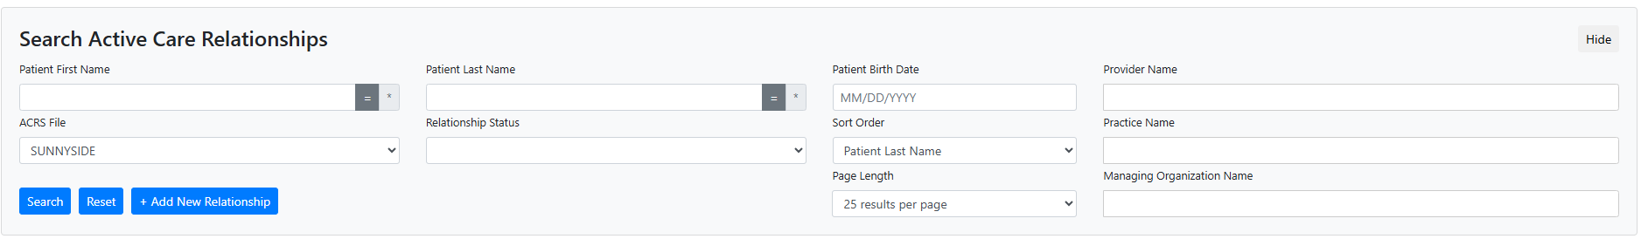
The “Search Active Care Relationships” interface is the main user interface element for Manage ACRS®, as shown in Figure 32.
Figure 32. Search Active Care Relationships Layout
The filter has several elements to look up information about applicable ACRS® files and the patients that are attributed to them. A breakdown of these elements is illustrated in Figures 33 and 34.
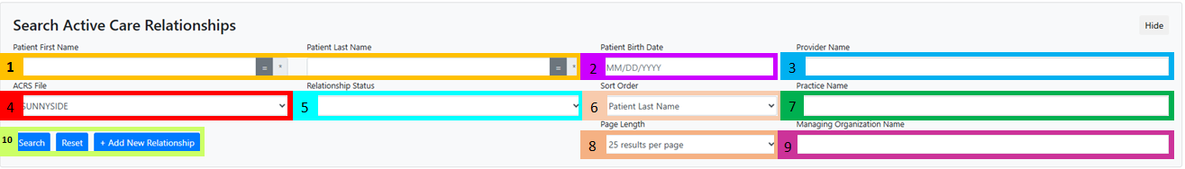
Figure 33. Search Active Care Relationships UI Elements

1 | Patient First/Last Name: Filter by patient first/last name with optional wildcard search function (for more information on wildcard searches, see appendix E)
2 | Patient Birth Date: Filter by patient date of birth (MM/DD/YYYY)
3 | Provider Name: Filter by Provider Name within ACRS® file  - Utilizes a text-completion field. Entering the first 2 letters of the providers’ name will start to display available provider names/NPI’s from the Health Directory
4 | ACRS® File: Filter by ACRS® file (applicable if organizations submit multiple ACRS files)
5 | Relationship Status: Filter by relationship status. Currently, only one status is searchable: Declared
6 | Sort Order: Sort results based on data elements (Patient Last Name, Provider Last Name, Practice Name)
7 | Practice Name: Filter by Practice Name within ACRS® file  - Utilizes a text-completion field. Entering the first 2 letters of the practices’ name will start to display available practice names/OIDs from the Health Directory
8 | - Page Length: Adjust results shown per page (25, 50, 100 or 200 results)
9 | Managing Organization Name: Filter by Managing Organization Name within ACRS file  - Utilizes a text-completion field. Entering the first 2 letters of the organizations’ name will start to display available organization names/OIDs from the Health Directory
10 | Search/Reset/+Add New Relationship:  - “Search” button will refresh page results with applied filter(s)  - “Reset” button will refresh page results with default Transitions of Care Viewer settings  - “+Add New Relationship” button will add new patient relationship(s) to ACRS® file
Figure 34. Search Active Care Relationships UI Element Descriptions
The resulting list of entries are laid out under the following headers as shown in Figure 35 and 36.
Figure 35. Search Active Care Relationships Results Headers
1 | Patient Name: Lists patient name, Gender, and Date of Birth in the following format:  - Last Name, First Name M.I.  (Gender) MM/DD/YYYY
2 | Patient Address: Lists patient address in the following format:  - Street Address  City, State, Zip Code
3 | Care Team Member/Practice: Lists Provider Last Name, First Name, NPI, Practice Name, and Practice OID of patient’s care team member in the following format:  - Last Name, First Name ((NPI))  Practice name ((Practice OID))
4 | Managing Organization: Lists the Name and OID of the organization managing the list of care team members and practices in the following format:  - Managing Organization Name ((Managing Org OID))
5 | Actions: Lists actions to be made with the Patient Entry:  - Relationship-Declared – Used to remove a declared relationship between patient and care team member  - Copy – Used to copy the relationship. This will open the entry to confirm details of the relationship  - Edit – Used to edit the details of the relationship
Figure 36. Search Active Care Relationships Results Header Descriptions

3.2.2 Working with ACRS® Populations


3.2.2.1 Adding and Removing Active Care Relationships
The Manage ACRS® module can be used to add active care relationships by clicking the “+Add New Relationship” button, as shown in Figure 37:
Figure 37. Add New Relationship Button
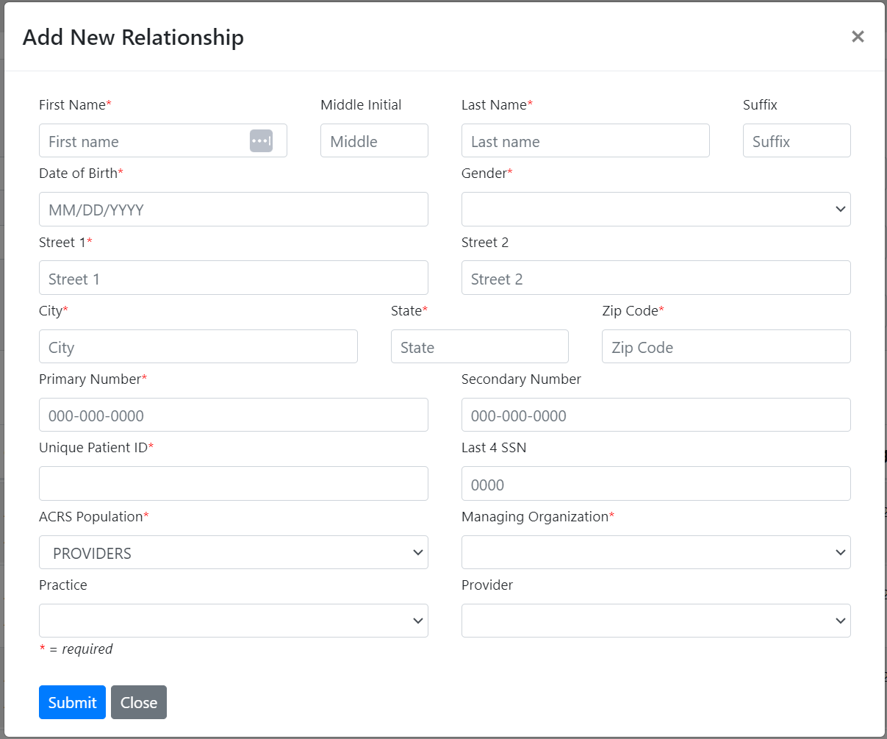
A window will appear, allowing the creation of a new active relationship by entering in the corresponding information, as pictured in Figure 38.
Figure 38. Add New Relationship Field Layout

The ACRS® Population, Managing Organization, Practice, and Provider fields are all text-completion fields that will be populated based on information in the Health Directory that was entered in the Search Active Care Relationships filter. Users will need to enter at least the first two letters of their Provider or Org Name in the field for it to begin to display available options matching their search criteria.
Several of the fields in the form are required to be completed prior to submitting the form. These fields are listed below, along with any specifications around the information required:
Required Field | Field Specifications
First Name | - First Name of patient as it appears in the health record
Last Name | - Last name of patient as it appears in the health record
Date of Birth | - Date of Birth in the format: DD/MM/YYYY
Gender | - Gender of the Patient as it appears in the health record
Street Address (Line 1) | - For unhoused/homeless patients, please populate “NOT AVAILABLE”
City | - For unhoused/homeless patients please populate Attributed Practice city
State | - For unhoused/homeless patients please populate with Attributed Practice State
Zip Code | - For unhoused/homeless patients please populate with Attributed Practice Zip Code
Primary Phone Number | - For unhoused/homeless patients, please populate with Attributed Practice Phone number
Unique Patient ID | - Enter a formal unique identifier (maximum of 40 characters) from your system (e.g. Medical Record Number). For optimal results, do NOT reuse the same number for multiple patients. This number is important for identity resolution and will impact the quality of patient matching.
ACRS® population | - The Name of the ACRS® File the patient will be attributed to. This entry will default to the ACRS® population selected in the Manage ACRS® Search Active Care Relationships filter when a user adds a new relationship.
Managing Organization | - When beginning to enter in the first two letters of a user’s organization from the “Managing Organization” type-ahead field. Please Note: There may be a slight delay when loading the list as it is a large list.  - If you still do not see your organization, please email help@mihin.org or submit a Help Desk ticket
Please Note: For unhoused/homeless patients that the Attributed Practice information is unknown, please list the associated information for the Managing Organization instead.
For any housed patients, if the user meets the field population and format requirements, the relationship can be created. We do not recommend, but also do not prevent, the use of default values if the information is unknown. The inclusion of default data may result in a patient mismatch, so it is critical to gather as much accurate, required information as possible. If the social security number (SSN) is known, we also highly recommend including that to enhance the patient matching rate.
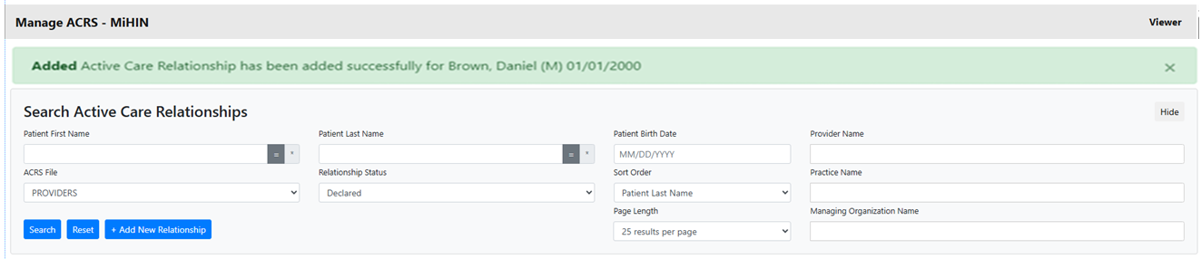
Once all required fields are populated, the user will click “Submit” and the Manage ACRS® module will reappear with a green banner at the top declaring that the new active relationship was successfully created as shown in Figure 39.
Figure 39. Successful Active Care Relationship Added Message
The newly created relationship should appear amongst the results for that population, though it may not appear on the first page, as the results are sorted alphabetically.
For more information and troubleshooting optional fields when adding new patients or relationships, please see Appendix I.

3.2.2.2 Copy/Edit Active Care Relationships
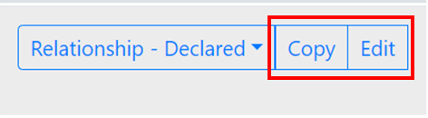
When an ACRS® file is selected and “Search” is done, it will display up to the first four hundred records attributed to that ACRS® file, along with information on that patient and the patient’s care team (if permissions allow). These active care relationship entries can be copied or edited as shown in Figure 40.
Figure 40. Copy and Edit Active Care Relationship Buttons
The “Copy” function will duplicate patient demographic data from the current entry and allow changes to be made and saved as a new active care relationship entry. The “Edit” function will allow the ability to update and save the current active care relationship entry. Clicking either of these options will display a pop-up window as shown in Figure 41.
This window allows fields to be updated before copying or to update the active relationship itself. Once the needed edits are made, the user can click the “Submit” button to complete the copy or update.

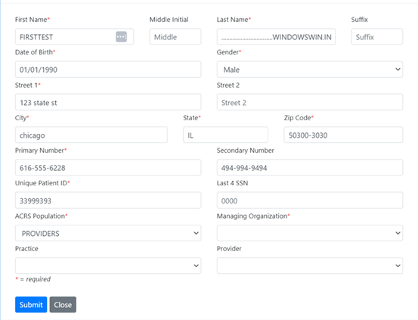
3.2.2.3 Removing Active Care Relationships
Figure 41. Edit/Copy Pop-Up Window Interface
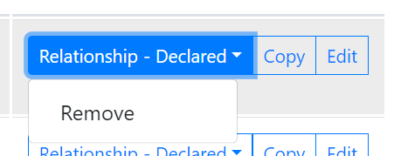
Deleting an active care relationship can also be accomplished through the Manage ACRS® module. In the same section as the “Copy” and “Edit” options, the “Relationship – Declared” button will display a “Remove” option when clicked as shown in Figure 42.
Figure 42. Remove Relationship Drop-down
When this option is selected, a confirmation window will be displayed. Clicking the “Remove” option will remove the relationship from the ACRS® file, as shown in Figure 43.
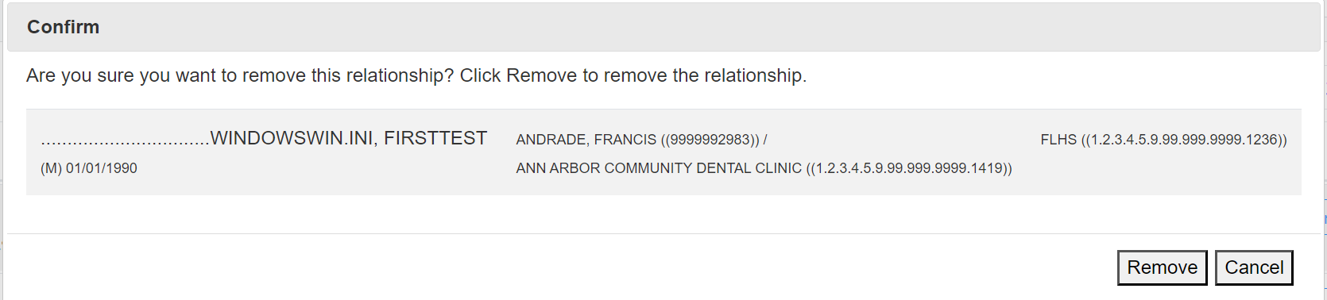
Figure 43. Remove Active Care Relationship Confirmation Screen

3.3 Patient Viewer
The Patient Viewer module allows users to view protected health information (PHI) related to patients they have existing relationships with and access additional embedded modules such as the Longitudinal Patient Record. If configured, the user can also create relationships with patients they do not currently have an existing relationship with using the ACRS® CareLink functionality within the Patient Viewer. Please see Section 3.3.2.4 for more information about using ACRS® CareLink.
The Patient Viewer module is also used in conjunction with other modules to display additional information about a patient. Depending on which modules the user has access to, Patient Viewer can be launched for any patient that is found through the following methods:
- Patient Search displayed on the MIGateway® homepage
- Patients displayed in the Manage ACRS® module
- Patients displayed in the TOC Viewer module

These modules will offer a list of patient identities to select from based on the user’s configuration and the search parameters entered. In the case of the Manage ACRS® module, the list will show attributed patients and their associated care team information. For the TOC Viewer module, the list will display encounter messages associated with the patient. In either situation, the patients included within these results can be selected to open the Patient Viewer.
The Patient Search module on the MIGateway® homepage will return a list of patients from either MiHIN’s enterprise Master Person Index (MPI) or from the user’s selected list of ACRS® populations depending on the user’s configured preferences.

3.3.1 Patient Viewer User Interface (UI) Elements and Views
The Patient Viewer module has several screens that are used to search for patients and provide information about patients found in other modules, including their care teams and the documents and messages associated with them.

3.3.1.1 Patient Search User Interface (UI)
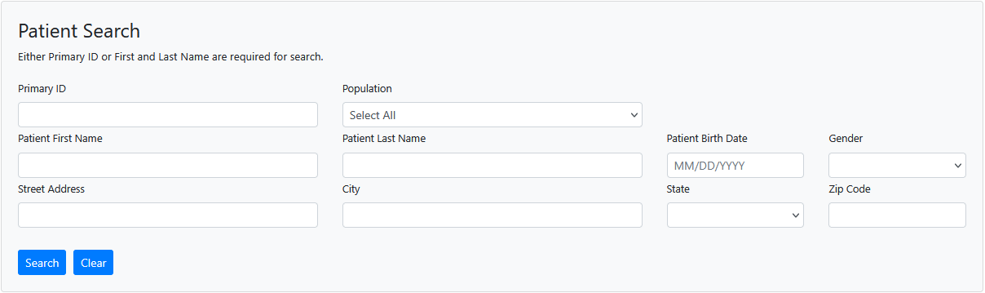
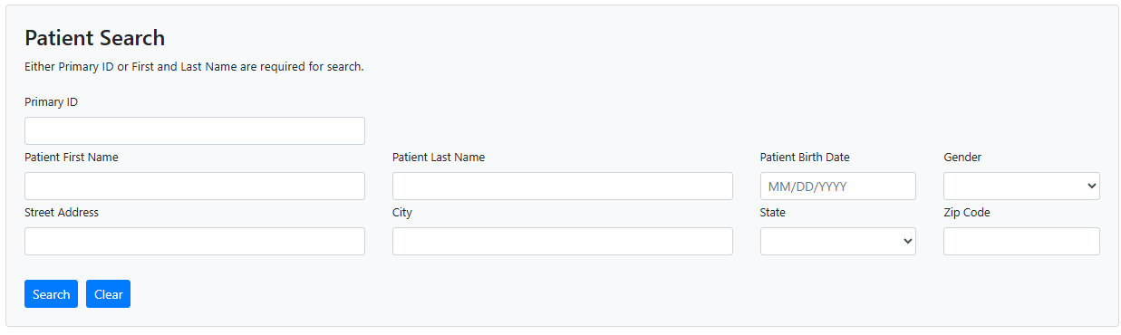
For users with access to the Patient Search module, the Patient Search UI can be accessed from the MIGateway® home page after logging in. Users configured to search MiHIN’s enterprise Master Patient Index via Patient Search will see a search screen as shown in Figure 44a. Users configured to search their own ACRS® populations will see a search screen as shown in Figure 44b. The difference is that users configured to search their own ACRS will have a Population dropdown from which to select all or specific populations to search.
Figure 44b. Patient Search UI Elements
Figure 44a. Patient Search UI Elements

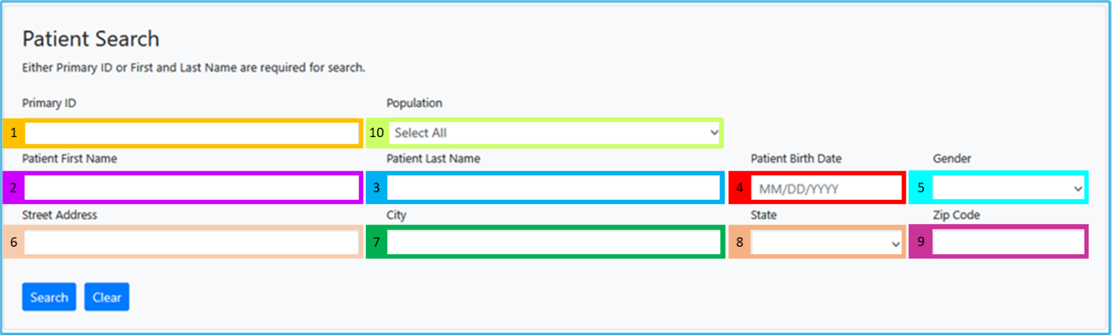
The Patient Search UI has several elements used to search against either the MPI or ACRS and filter all patients based on the search criteria entered in the Primary ID or First and Last Name fields. There are also result headers to indicate the patient demographics returned for each result in the list. These are described in Figures 45-48.

5

9
Figure 45. Patient Search UI Elements
1 | Primary ID: Filters by the unique identifier assigned to the patient by the managing organization as part of their MPI record or ACRS® attribution entry. This ID is established and used at the discretion of the managing organization that provided it. This field is case sensitive.
2 | Patient First Name: Filters patients by the first name of patients listed in the in the MPI or selected ACRS® population.
3 | Patient Last Name: Filters patients by the last name of patients listed in the MPI or selected ACRS® population.
4 | Patient Birth Date: Filters patients listed in the MPI or selected ACRS® population by the selected date of birth, entered in the format: MM/DD/YYYY
5 | Gender: Filters patients listed in the MPI or selected ACRS® population by the selected gender from the following list:  - M – Male  - F – Female  - O – Other  - U - Unknown
6 | Street Address: Filters patients listed in the MPI or selected ACRS® population by their address in the format: Street Number Street Name
7 | City: Filters patients listed in the MPI or selected ACRS® population by listed city.
8 | State: Filters patients listed in the MPI or selected ACRS® population by listed state.
9 | Zip Code: Filters patients listed in the MPI or selected ACRS® population by entered 5-digit zip code
10 | Population: If the user is configured to use Patient Search with ACRS®, this element will be available to filter the patient search to either all of the user’s ACRS® populations (if ACRS® populations) or only the ACRS® population selected from the dropdown.
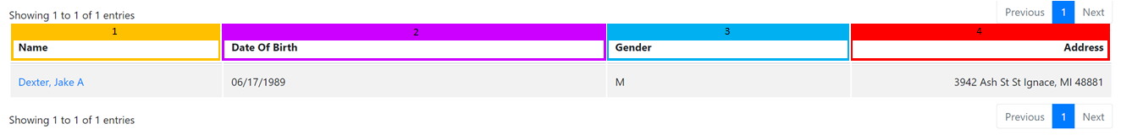
Figure 46. Patient Search UI Element Descriptions
Figure 47. Patient Search Result UI
1 | Name: Lists names of all patients meeting search criteria in alphabetical order, in the format: Last Name, First Name, Middle Initial
2 | Date of Birth: Lists associated date of birth for all patients meeting search criteria in the format: MM/DD/YYYY
3 | Gender: Lists associated gender for all patients meeting search criteria from the following list:  - M – Male  - F – Female  - O – Other  - U - Unknown
4 | Address: Lists associated address for all patients meeting search criteria in the format: Street Number, Street Name, City, State, Zip Code
Figure 48. Patient Search Result Header UI Descriptions

3.3.1.2 Viewer UI
Clicking on the name of a patient listed in the Patient Search results will open another screen with more detailed information about the patient, including their care team, documents associated with them, their consent information, as well as links to their associated longitudinal record entry. These results can also be found in the Manage ACRS and TOC Viewer modules as well. This screen has display and UI elements as illustrated in Figures 49-56.
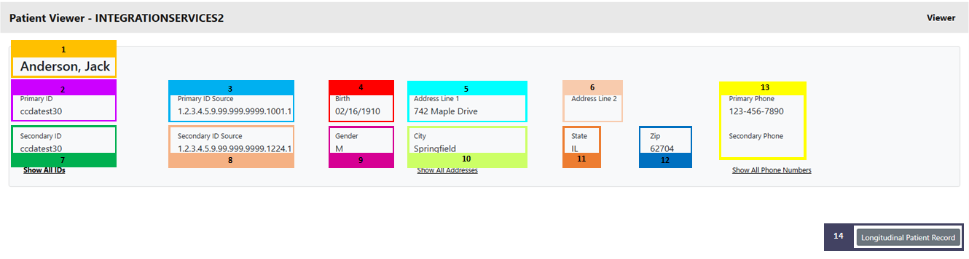
Patient Summary
Figure 49. Patient Summary UI Elements
1 | Patient Name: Displays the name of the selected patient in the format: Last Name, First Name
2 | Primary ID: Displays the primary unique identifier associated with the patient that is provided by the managing organization as part of their ACRS® attribution entry. This ID is established and used at the discretion of the managing organization that provided it.
3 | Primary ID Source: Displays the OID of primary organization and facilities responsible for generating the patient data.
4 | Birth: Displays the patient’s date of birth in the format: MM/DD/YYYY
5 | Address Line 1: Displays the primary address for patient in the format: Street Number, Street Name
6 | Address Line 2: Displays secondary address information including the following:  - Unit/Apt Number  - P.O. Box Number
7 | Secondary ID: Displays the secondary identifier associated with the patient that is provided by the managing organization as part of their ACRS® attribution entry. This ID is established and used at the discretion of the managing organization that provided it.
8 | Secondary ID Source: Displays the OID of secondary organization and facilities responsible for generating the patient data.
9 | Gender: Displays patient’s listed gender from the following options:  - M – Male  - F – Female  - O – Other  - U - Unknown
10 | City: Displays patient’s city of residence
11 | State: Displays patient’s state of residence
12 | Zip: Displays patient’s 5-digit zip code of residence
13 | Primary Phone and Secondary Phone: Displays patient’s primary phone number, including area code, and any additional phone number associated with the patient.
14 | Longitudinal Record: Clicking this button will open an additional window that will display the full longitudinal record for the selected patient. The Longitudinal Record module will be covered in greater detail in section 3.6.
Figure 50. Patient Summary UI Element Descriptions
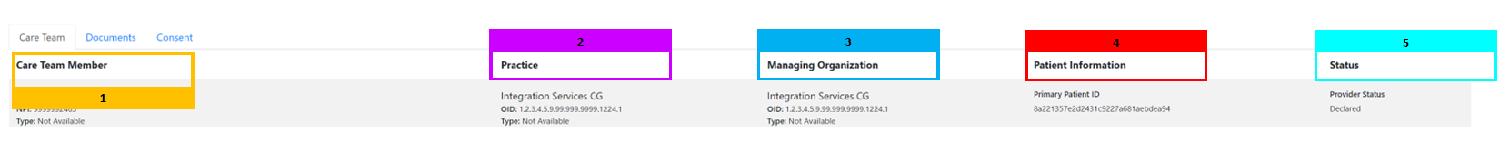
Care Team Tab
Figure 51. Care Team Tab Headers
1 | Care Member Team: Lists all members of a patient’s care team, along with additional details including:  - Name in the format: Last Name, First Name  - NPI  - Type  - Specialties  - Direct Address  - Phone Number
2 | Practice: Lists information about the practice associated with each Care Team Member, including:  - Practice OID  - Type  - Phone Number  - Address
3 | Managing Organization: Lists information about the managing organization for the Care Team Member, including:  - Managing Organization OID  - Type  - Phone Number  - Address
4 | Patient Information: Lists some of the same information displayed in the patient summary display for the patient, including:  - Primary Patient ID  - Patient Address in the format: Street Number, Street Name, City, State, Zip Code
5 | Status: Lists the status of the Care Team Member’s provider and consumer relationship with the patient:  - Declared
Figure 52. Care Team Tab Header Descriptions
Documents Tab (If configured for Intelligent Query Broker)
Figure 53. Documents Tab Headers
1 | Document Name: Displays a list of documents associated with the patient, including the following:  - Summarization of Episode Notes
2 | Document Type: Displays CCD documents. The documents displayed may have many different names depending on the providing organization. The CCDs are retrieved from federated calls. The documents may include the following:  - Summarization of Episode Notes (90% of documents)  - Other (For a complete list of documents that may be present in this field, please see 4.7 Appendix G – C-CDA Documents.
3 | Document Date: Displays the creation date for each listed document in the format: YYYYMMDD050000 (entire time stamp of the creation date)
4 | Document Source: Displays the organization or location from where the document was produced and is kept.
5 | Actions: Lists actions that can be taken by the user to interact with the listed document, including:  - View – Opens a more detailed window view of the entire listed document  - XML – Export the document in raw XML format  - PDF – Export the document in human-readable PDF format
Figure 54. Documents Tab Header Descriptions
Consent Tab
Figure 55. Consent Tab Headers
1 | Form Name: Displays the name of both the Active and Inactive consent forms on file for the patient
2 | Active Until Date: Displays the last date active consent forms will be usable for consent-related processes and the last date that inactive consent forms were usable for consent-related processes
3 | Provider: Displays the provider that the active and inactive consent forms authorized
4 | Practice: Displays the practice associated with the provider that the active and inactive consent forms authorized
5 | Document Source: Lists the source of the active and inactive consent forms
6 | Action: Displays actions available for users to interact with the listed active and inactive consent forms, including:  - PDF – Export the document in human-readable PDF format
Figure 56. Consent Tab Header Descriptions

3.3.2 Using the Patient Viewer Module
Users can access the information found within the Patient Viewer module from any other module that pulls up and displays a list of patients. Patients can also be searched for directly by using the Patient Search function.

3.3.2.1 Searching for a Patient
If users have been set up for the Home Patient Search during their account configuration, the user can use the Patient Search function to enter search criteria that will filter the list of patients from either the MPI or the user’s ACRS® population that best matches the criteria provided in the search fields.
Search criteria fields and requirements include either the Primary/Unique Patient ID or the First and Last Names. With this information, users can use the Patient Search function to find up to 10 matching identities with an exact match to the entered information. These are also defined in detail in section 3.3.1.1. Once all needed fields have been defined, click the “Search” button to filter the results.
Please Note: In situations where a Patient Birth Date is used along with the First Name and Last Name in a search, the results returned could match on either the first OR last name plus the date of birth, NOT the first AND last name plus the date of birth.
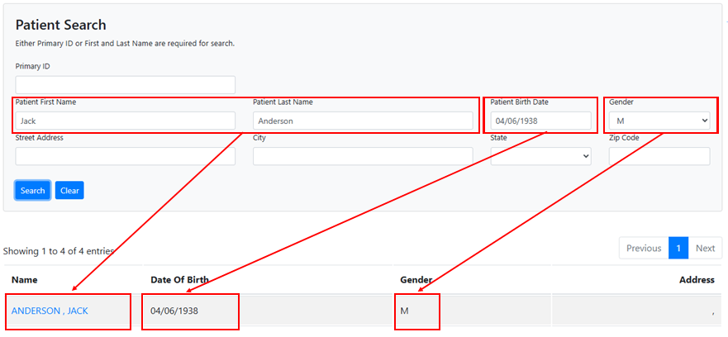
A list of patients that meet the specified search criteria will be listed below the Patient Search menu, as shown in Figure 57.
Figure 57. Patient Search Filter Entries and Results

This list shows basic information associated with each patient such as Date of Birth, Gender, and Address. It also provides a link on the patient’s name that can be clicked to see more detailed information and other tools that can be used to work with the patient’s entry as shown in Figure 58.
Figure 58. Patient Viewer Link

3.3.2.2 Working with Patient Viewer Entries Patient Summary
When a specific patient’s name is clicked on, a new window will open, displaying a much more detailed summary for the patient, as shown in Figure 59.
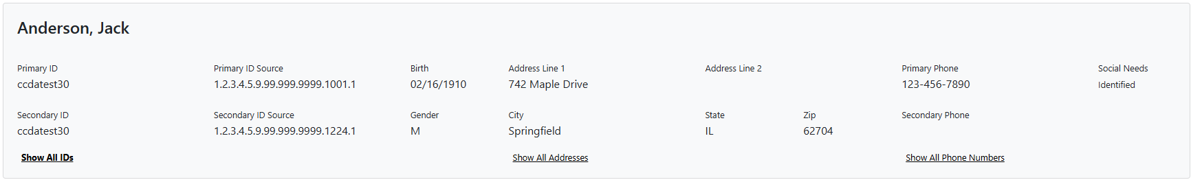
This summary includes all the information displayed on the previous page, but includes additional information such as the following:
Figure 59. Patient Summary Screen
- Primary and Secondary Phone Numbers
- Primary and Secondary ID Source
- Secondary ID
- Address Line 2
These entries are defined in detail in section 3.3.1.2. Additionally, the “Longitudinal Patient Record” button located on the lower right-hand corner will take the user to the patient’s detailed longitudinal record view, which will be covered in greater detail in section 3.6.
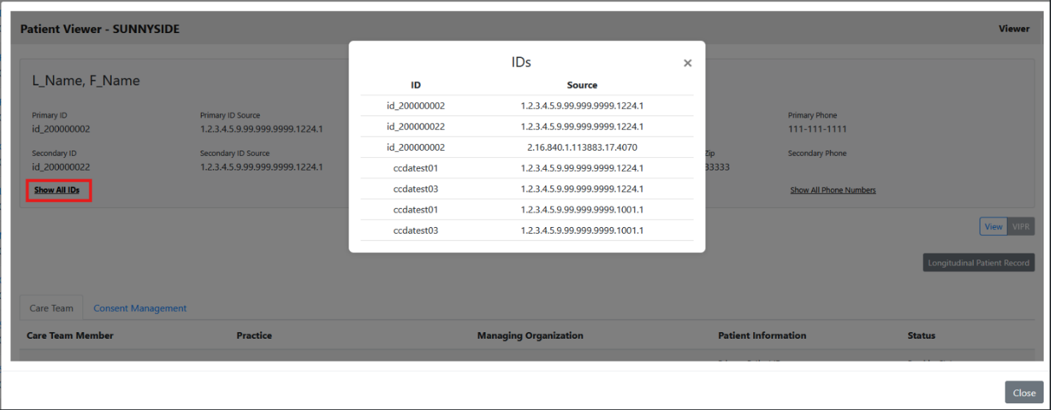
On the left-hand side of the interface, a “Show All IDs” link can be clicked to provide a list of all IDs for the patient and their source, displayed as the source organization OID as illustrated in Figure 60.
Figure 60. Patient Viewer ID Display Window
Similar links can be found for “Show All Addresses” and “Show All Phone Numbers”, which function similarly, displaying all Addresses or Phone Numbers for a patient and their source, respectively.
In addition to the Patient Summary, if enabled during account setup and configuration, there are three tabs displayed for each patient that list information about the patient’s care team members, any documents associated with the patient, and any Electronic Consent Management Services Use Case (eCMS) documents associated with the patient on file (this will be available soon).
Viewing Care Team Information
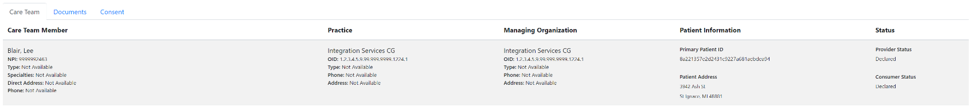
If a user’s permissions are configured to do so, they can view a summary of care team information for the patient in the care team tab, which lists all members of a patient’s care team across all loaded ACRS® populations, as shown in Figure 61. Users can review information about care team members by clicking this tab.
Figure 61. Care Team Tab View
This information includes:
- Care Team Member Details
- Details about the practice of which the care team member is a part of
- Details about the Managing Organization of the practice/care team member
- Patient Information that reiterates details from the ACRS file that the patient is attributed to
- The current provider and consumer status between the patient and care team member.
Viewing Patient Documents
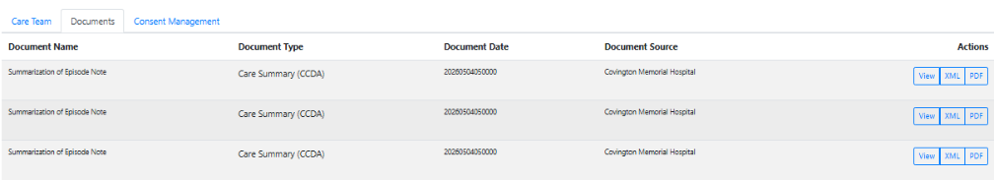
Users can utilize the documents tab to view a summary list of all care documents on file for a selected patient. This tab also includes tools that allow a user to access a complete view of listed documents as shown in Figure 62.
Figure 62. Documents Tab Display

In this tab, users can view a summary list of all documents on file associated with the chosen including:
- The name of all documents listed
- The type of document each named document is
- The date the document was created
- The source of the document
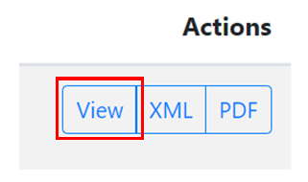
Additionally, under the “Actions” header, the “View” button can be used to view all the information included in a listed document as shown in Figure 63.
Figure 63. View Button to View Full Documents
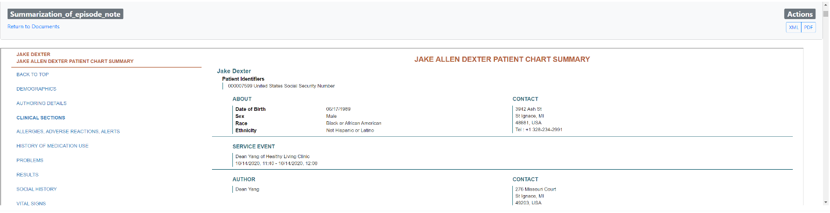
The resulting view lists all information included in the listed document and can vary depending on the document listed. Figure 64 is an example of a detailed view of a Summarization of Episode Note while using this view:
Figure 64. Summarization of Episode Note Example
Please Note: The Documents Tab will only be present if users have been configured for Intelligent Query Broker.

Viewing Consent Information
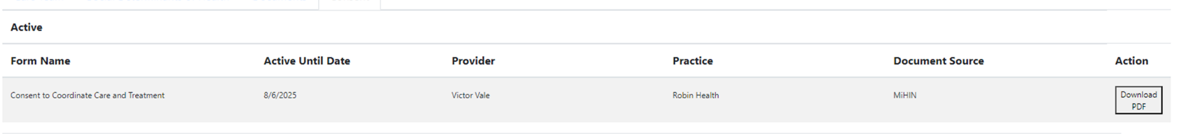
The Patient Viewer module can also be used to view available patient consent documents as shown in Figure 65. This is accomplished by clicking on the “Consent” tab under the patient summary.
Figure 65. Consent Tab Screen
Please note: While information is included in this user guide, the eCMS module is still being finished and will only be available in a future version of MIGateway® after its initial release. When available, the “Consent” tab will only be present for users that have signed up for the eCMS Module.
The resulting view lists all active and inactive consent forms on file, as well as summary information about each consent form, including:
- The date the form is/was active until
- The provider that the consent authorized for use
- The practice that the listed provider was a part of
- The source of the consent document
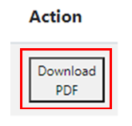
A more detailed view of the complete consent document can be reviewed by clicking the “Download PDF” button under “Actions” as shown in Figure 66.
Figure 66. View Documents Button

3.3.2.3 Exporting Patient Documents and Consent Forms
In addition to viewing the documents and consent forms listed for each patient, selected documents and consent forms can be exported for use. In either case, the user will select the format they wish to export the document in. The options can vary depending on the document, but in general, the options available are:
- XML – Export the raw XML file for a CCD (May not be applicable for all document types)
- PDF – Export a human-readable version of the document
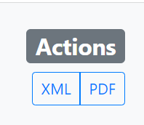
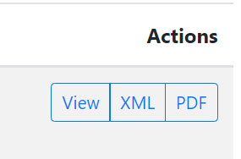
Once the user has determined what format the document should be exported in, they will click the appropriate button under the “Action” header in the patient summary view, or alternatively, can click the appropriate format option within the detailed document view itself, also under the “Action” header as shown in Figures 67 and 68.
Figure 67. Document Format Export Options in Patient Summary
Figure 68. Document Format Export Options Within Document View
Once selected, MIGateway® will generate the document in the chosen format and download it to the user’s system. An example of an exported PDF is displayed in Figure 69.
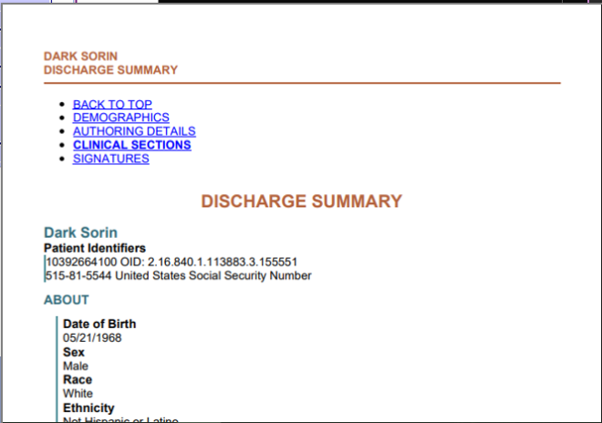
Figure 69. Chart Summary PDF Example

3.3.2.4 Using ACRS® CareLink
As mentioned previously, if a user is configured in their MIGateway profile, the Patient Viewer module has the ability to enable users to quickly and easily create new ACRS® relationships with patients they don’t currently have one with. This functionality is referred to as ACRS® CareLink.
In situations where the User is associated with an ACRS® population that has an active care relationship established with the patient launched for view in the Patient Viewer, they will be allowed to view additional data for the patient including data included in the Longitudinal Record Viewer as shown in Figure 70.

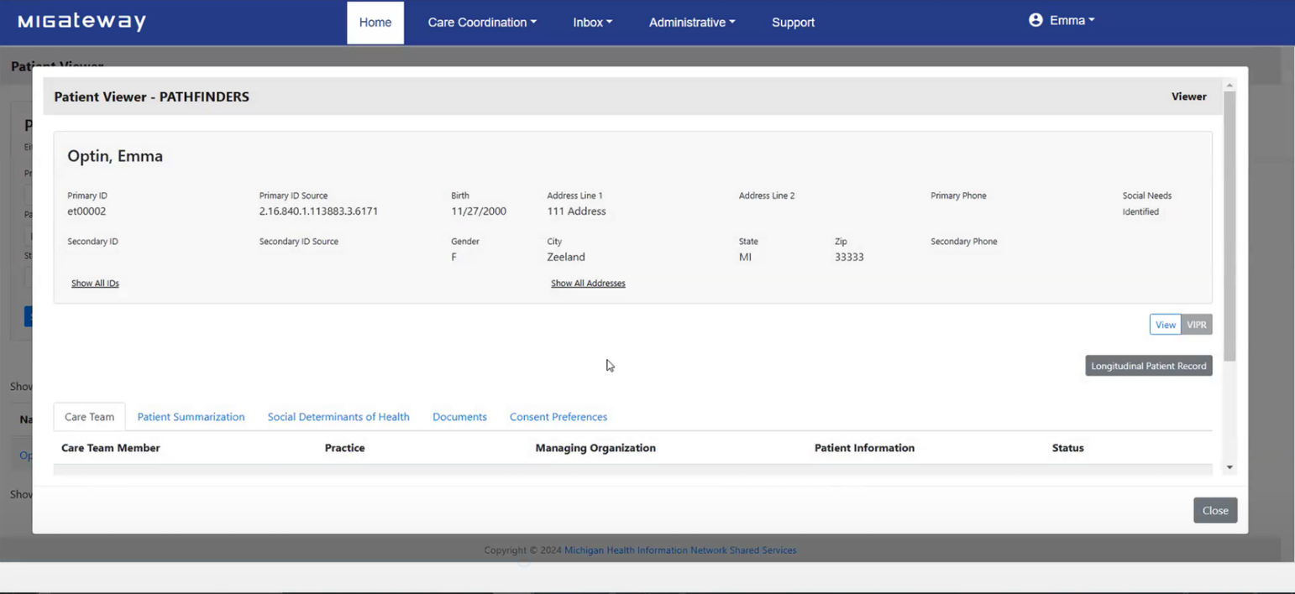
Figure 70. Longitudinal Record Information Accessible to Users with Established ACRS® Relationship with Patient
If, however, the User is not associated with an ACRS® population that contains an active care relationship with the patient launched for view in the Patient Viewer, the User may utilize the ACRS® CareLink functionality to declare a relationship with the patient. This is accomplished by creating a relationship on the following screen as shown in Figure 71.
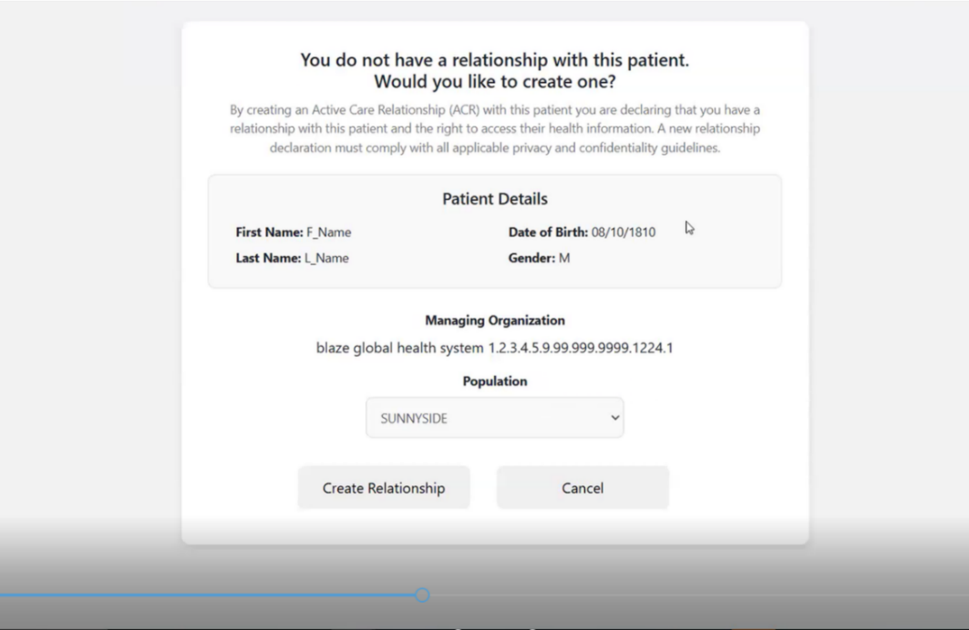
The user will choose the ACRS® population they want the relationship to exist in and then click the “Create Relationship” button. Once created, the User can view additional information for the patient including data found in the Longitudinal Record, like that found in Figure 71.
Figure 71. ACRS® Relationship Creation Pop-up Screen
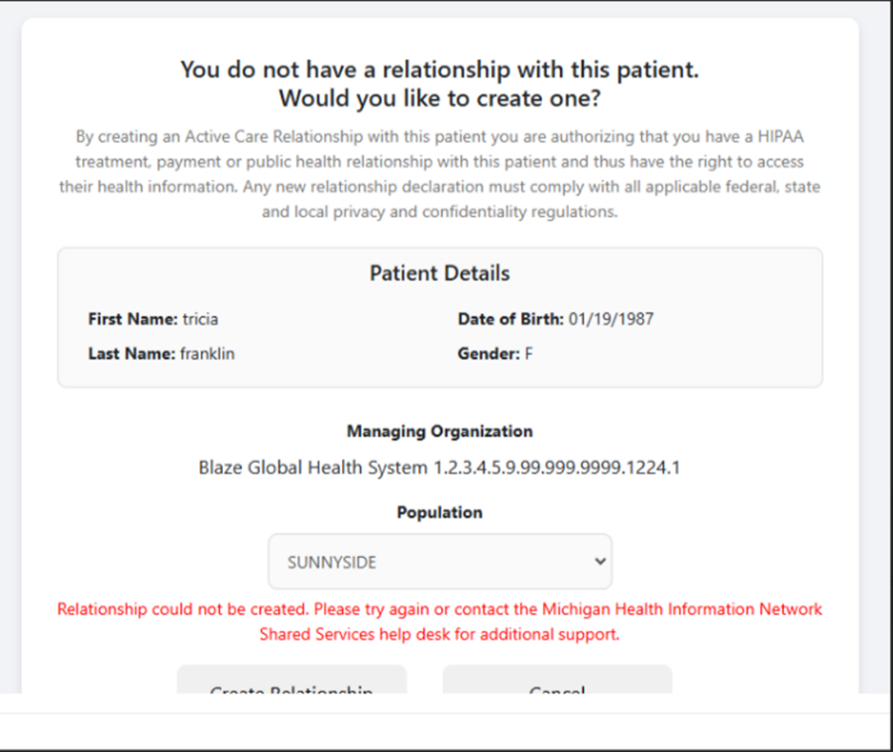
In situations where the User is not granted permission to create an active care relationship, when the attempt to click on the patient they will be shown an error message like the one shown in Figure 72.
Figure 72. Error Message for Patients that User Does Not have an Active Care Relationship With

3.4 Transitions of Care (TOC) Viewer
Users can view various electronic messages regarding patients in the Transition of Care (TOC) Viewer, including the following message types:
- Admission, Discharge, Transfer Notifications
- Discharge Medication Reconciliation
- Ambulatory CCDs
The features included with the TOC Viewer allow users to:
- See human-readable versions of ADT Notifications that are sent for patients
- Filter received ADT notifications for a given message type, patient, organization, etc.
- View medication reconciliation messages that are associated with specific ADT notifications (A03 event types)
- Work through a notification queue and act on messages

3.4.1 TOC Viewer UI Elements
TOC Viewer can be accessed by navigating to the Care Coordination dropdown and selecting the TOC Viewer option, as illustrated in Figure 73.

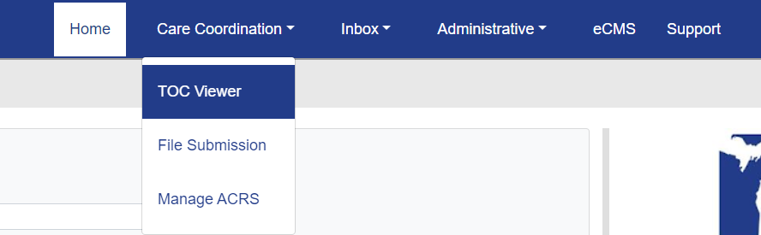
Figure 73. TOC Viewer Menu Location

3.4.1.1 TOC Viewer - ADT Filter View
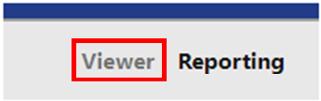
The main user interface element used within the TOC Viewer module is the ADT Filter, which can be selected by clicking the “Viewer” option in the upper right-hand corner of the screen as shown in Figures 74 and 75. 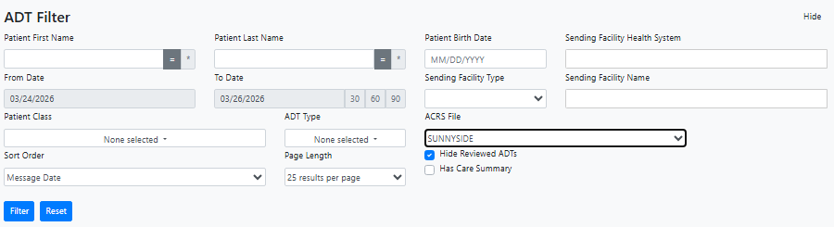
Figure 74. ADT Filter Screen Layout
Figure 75. Viewer Tab Location

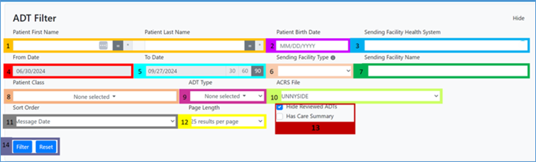
The filter has several elements to search for and look up information about applicable ADT and Med Rec messages. A breakdown of these elements is illustrated in Figures 76 and 77.
Figure 76. ADT Filter UI Elements
1 | Patient First and Last Name: Filter by patient first/last name with optional wildcard search functions (for more information on wildcard searches, see Appendix 4.5 E)
2 | Patient Birth Date: Filter by patient date of birth in the format: MM/DD/YYYY
3 | Sending Facility Health System: Filter for ADTs by health system or parent organization.  - Type at least the first two letters of a sending facility health system for a list of suggestions to appear: Continue typing the name to narrow down results.
4 | From Date: Filter by specific start date
5 | To Date: Filter by specific end date within 90 days or 30, 60, 90-day date range
6 | Sending Facility Type: Filter by facility type:  - Hospital  - SNF (Skilled Nursing Facility)  - Home Health  Used to filter suggestions within the “Sending Facility Name” field; or as a stand-alone filter for ADTs from facilities of that selected type.
7 | Sending Facility Name: Filter for ADTs by sending facility.  - Type at least the first two letters of a sending facility for a list of suggestions to appear: Continue typing the name to narrow down results.
8 | Patient Class: Filter by patient class:  - Inpatient  - Outpatient  - Emergency  - Observation
9 | ADT Type: Filter to view messages of specific event types from the following:  - Admission (A01)  - Transfer (A02)  - Discharge (A03)  - Register (A04)  - OP to IP (A06)  Please Note: Having the “Select All” option has the same functionality as “None Selected” as the TOC viewer will only be looking at A01, A02, A03, A04, and A06 message types.
10 | ACRS® File: Filter to view multiple Active Care Relationship Service (ACRS®) patient populations (if applicable)
11 | Sort Order: Sort results based on data elements:  - Message Date  - Patient Name  - ADT Type
12 | Page Length: Adjust results shown per page (25, 50, 100 or 200 results)
13 | Hide Reviewed ADTs/Has Care Summary: Selecting either of these check boxes will refine the search to include messages already reviewed by the user and/or refine the search to only show ADTs that have a care summary, respectively. The “Hide Reviewed ADTs” box is checked by default.
14 | Filter/Reset: The “Filter” button will refresh page results with applied filter(s). The “Reset” button will refresh page results with default TOC Viewer settings.
Figure 77. ADT Filter UI Element Descriptions
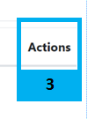
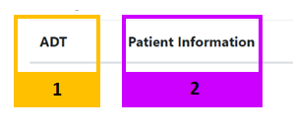
After the filter has been configured and refreshed, all TOC message entries meeting the search criteria are displayed under the headers shown in Figures 78 and 79.
Figure 78. TOC Viewer Message Result Headers
1 | ADT: Displays the event type associated with the displayed messages:  - Admission (A01)  - Transfer (A02)  - Discharge (A03)  - Register (A04)  - OP to IP (A06)
2 | Patient Information: Lists information about the patient associated with the displayed TOC message:  - Name of the patient, date of birth, location of event type, and date of encounter  - Provider  - Message Date/Time  - Patient Class  - Diagnosis Type  - Diagnosis  - Insurance Company Name  - Admission Type  - Admit Reason  - Assigned Location Admission Time (A01)  - Discharge Disposition (A03)  - Discharge Location (A03)  - Discharge Time (A03)  Note: Some patient information entries may indicate that the patient associated with the selected messages is deceased. This status is marked with the  symbol. Hovering over this symbol will display the message, “Patient is marked as deceased.”
3 | Actions: Lists several actions that can be taken to see additional views associated with the TOC message, the associated patient, and the CCD, including the following:  - Care Summary – If applicable  - View  - HL7  - PDF
Figure 79. TOC Viewer Message Result Header Descriptions

3.4.1.2 TOC Viewer – Reporting
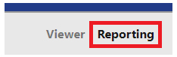
The TOC Viewer – Reporting interface is accessed by clicking the “Reporting” option in the upper righthand corner of the TOC Viewer Screen, as pictured in Figure 80.
Figure 80. TOC Viewer - Reporting Button
The resulting screen has several UI elements used in generating report information relevant in Meaningful Use Stage 3 attestations, which will be covered in greater detail in section 3.4.2.3. The UI elements are as shown in Figures 81 and 82.
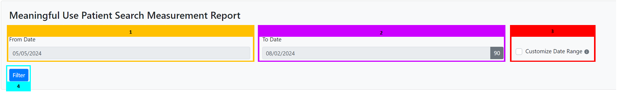
Figure 81. Meaningful Use Reporting UI Elements
1 | From Date: Earliest date in the range that the user would like to run a report on Patient Search metrics (maximum range of 90 days)
2 | To Date: Latest date in the range that the user would like to run a report on Patient Search Metrics (maximum r of 90 days)
3 | Customize Date Range: When checked, allows users to run a report on Patient Search metrics outside of the maximum 90-day range
4 | Filter: Filters results based on the above criteria and produces results within the specified range of dates
Figure 82. Meaningful Use Reporting UI Element Descriptions

3.4.2 Working with Transitions of Care Messages

3.4.2.1 ADT and Care Summary Overview
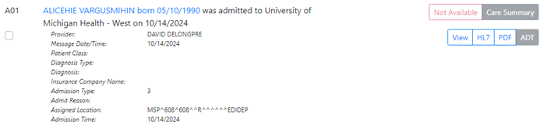
A List of messages and corresponding patients appear after criteria have been defined in the ADT Filer. Figure 83 shows an example of the ADT message overview.
Figure 83. ADT Message Overview Example
Clicking on the patient’s name/date of birth will open the Patient Viewer page for the patient. More information on this module and view is covered in Section 3.3.
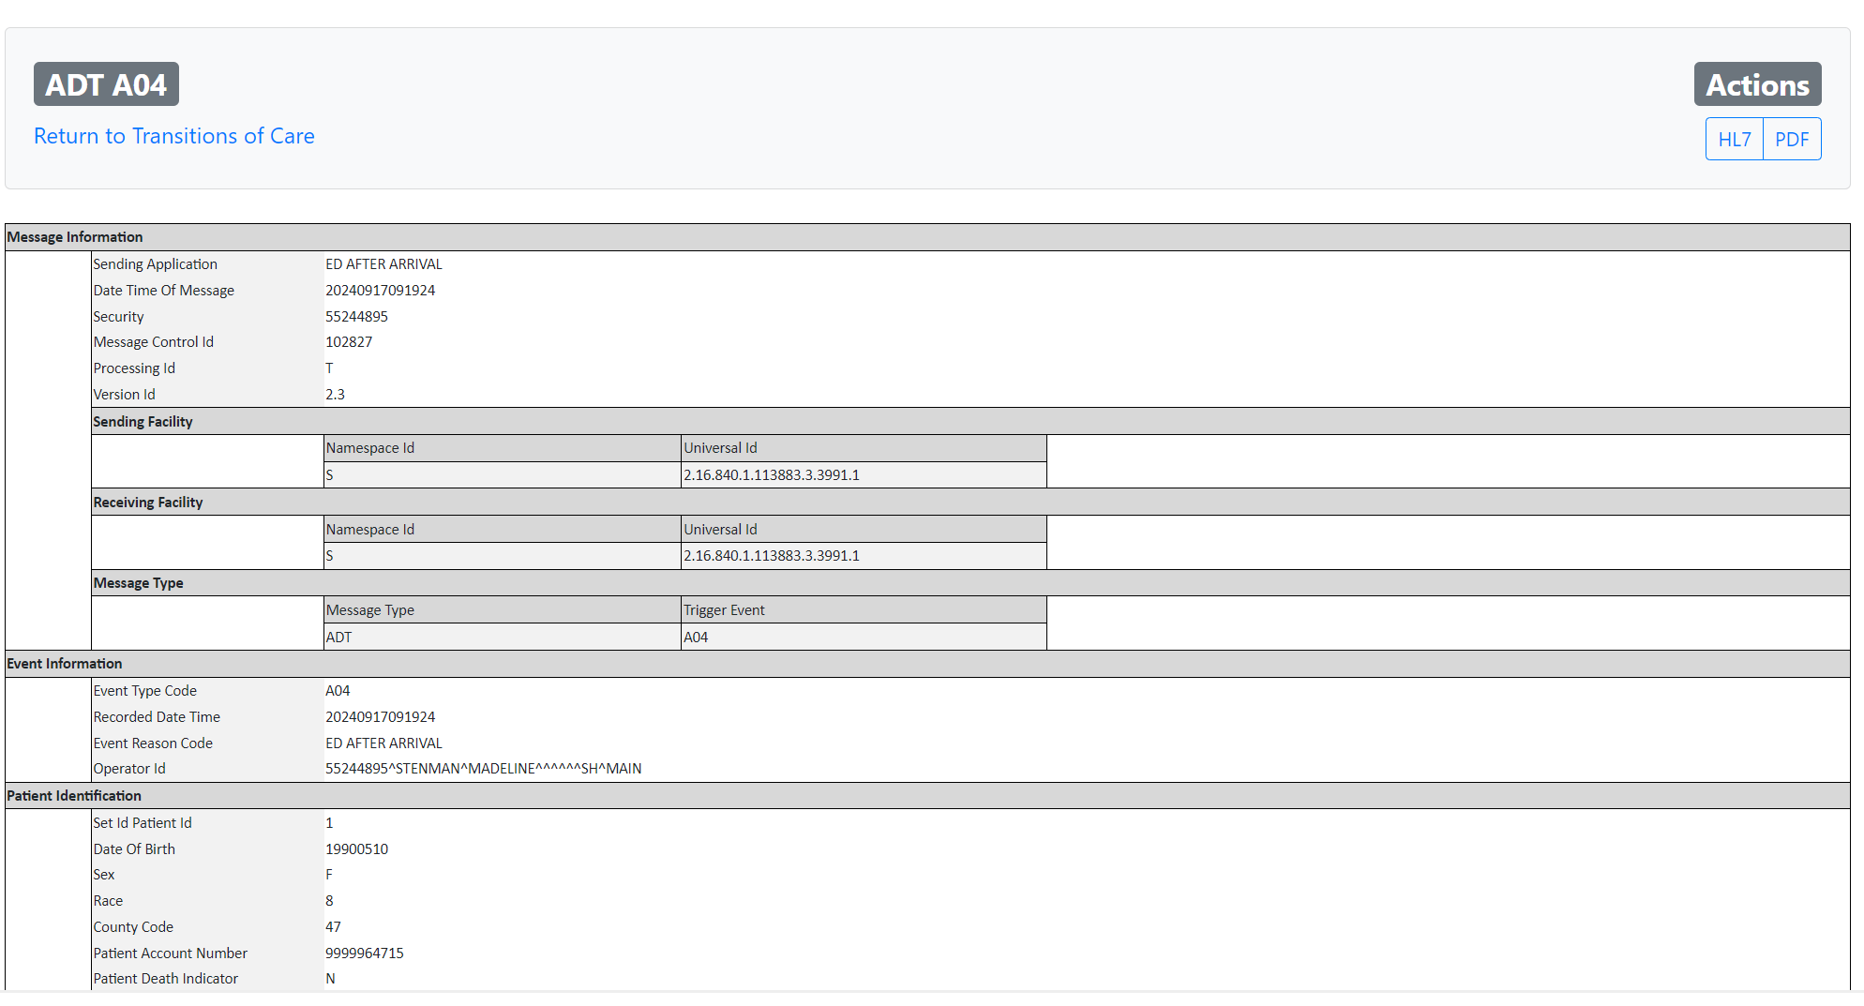
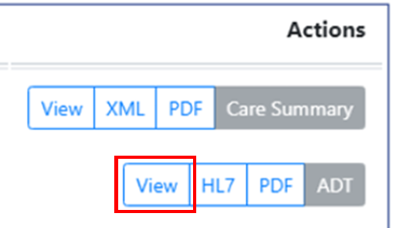
Clicking the “View” Button, as shown in Figure 84, will open an additional screen showing the full ADT message for the patient as shown in Figure 85.
Figure 84. View Button for Full ADT View

Figure 85. Full ADT Message View
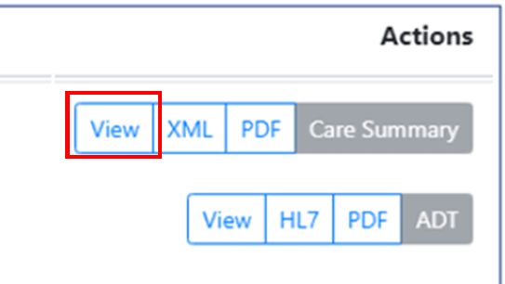
Additionally, users can view a more detailed discharge care summary CCD by clicking the other “View” button next to Care Summary under the “Actions” header, as shown in Figure 86.
Figure 86. View Button for Complete Care Summary View
In the resulting view, the full Discharge Care Summary is displayed as shown as illustrated in Figure 87.
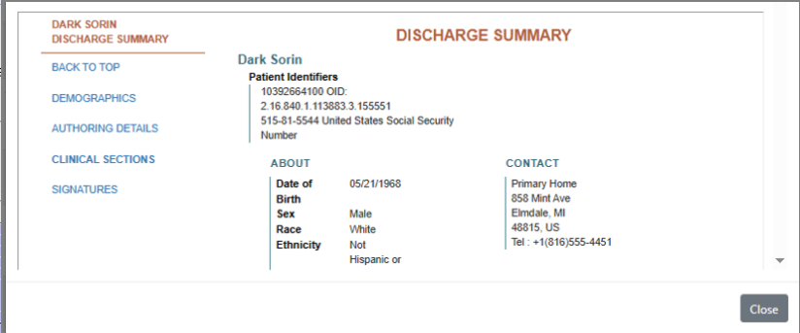
Figure 87. Discharge Care Summary Example

3.4.2.2 Exporting ADTs and Care Summaries
The TOC viewer also offers export options for both ADT and Care Summary messages. These can be found in the same areas as the “View” buttons described in the previous section under the “Actions” header. These can be exported in the formats shown in Figures 88 and 89, depending on which summary is needed:
Care Summary Export Options:
- XML: Download the raw care summary XML file

- PDF: Download the human readable Care Summary in PDF format
Figure 88. Care Summary Export Option Buttons
ADT Export Options:
- HL7: Download the raw HL7 ADT File

- PDF: Download the human readable ADT in PDF format
Figure 89. ADT Message Export Option Buttons
Note: Only Discharge ADTs (A03) will have an associated Care Summary attached to the ADT Notification. Additionally, the following information must match what is included in the A03 ADT, as well as the Care Summary, for the CCD to be attached to the A03 ADT Notification:
- Patient First Name
- Patient Last Name
- Patient Date of Birth
- Patient Gender
- Encounter ID/Visit ID
Additionally, export options are also available for the detailed ADT and Care Summary message view as HL7, XML, or PDF options, as shown in Figures 90 and 91.
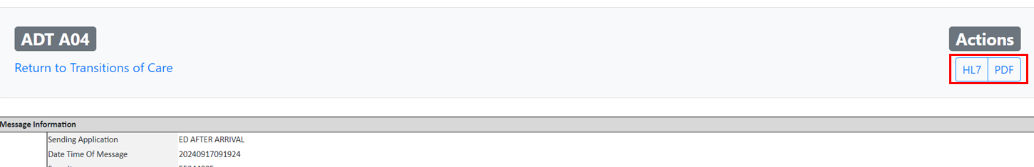
Figure 90. ADT Message Export Options
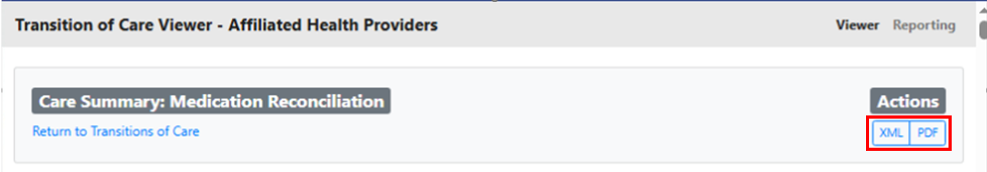
Figure 91. Care Summary Message Export Options

3.4.3 Reporting with TOC Viewer

3.4.3.1 Meaningful Use Patient Search Measure Report
The TOC Viewer Reporting functionality can generate reports to show how many patients the user successfully searched for during a given 90-day period. This data is useful in Meaningful Use Reporting attestations. This reporting functionality allows the user to do the following:
- Filter based on a specified period to see the number of patients successfully searched in TOC Viewer when the patient’s first name, last name, and date of birth are entered
- The data also includes the number of patients found, as well as the number of patients found with a CCD
- Download a PDF version of the report to support Meaningful Use Stage 3 attestations
For a patient to be counted in the report, a patient’s first name, last name, and date of birth must have been searched during the time range set by the filter. If only the first name and last name are provided while using TOC viewer and one or more patients are returned, they will not be counted in the report.
To run the report, a user must select a date range using the options outlined previously in section 3.4.1.2. Once selected, clicking the “Filter” button will generate a report with two sections: a high-level overview of the results and a table of patients the user has searched. These are covered in greater detail below:
Results Overview
At the top of the results section, information is returned on the established search criteria, including the date the report was ran and the date range provided in the filter menu. This includes the following information:
- Total Patients Searched – Number of patients searched for during the chosen search date range using first name, last name, and date of birth
- Total Patients Returned in Search
- Total Patients Returned in Search with a CCD
An example of this report is shown in Figure 92, along with its search criteria.
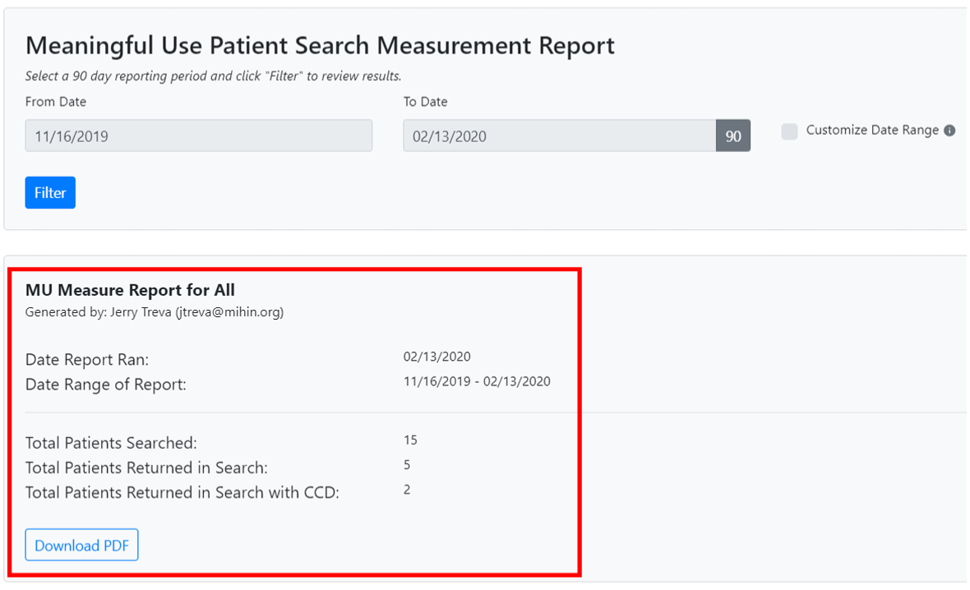
Figure 92. Meaningful Use Patient Search Measurement Report Results
Searched Patient Table
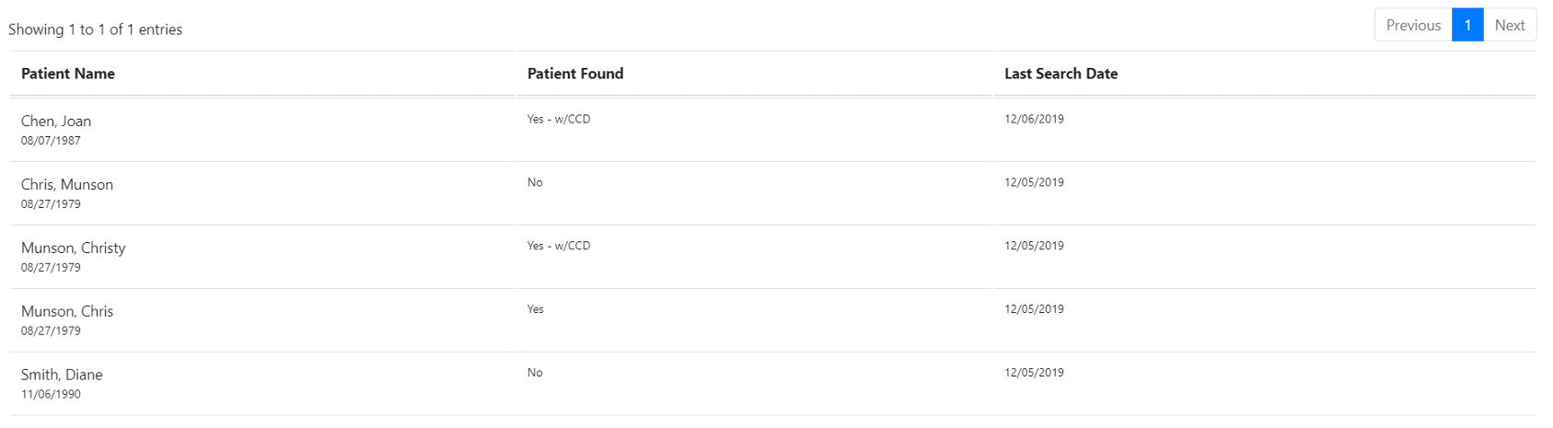
Search data that meets the criteria will also be displayed in a table within the user interface, as shown in Figure 93.
Figure 93. Meaningful Use Patient Search Measurement Report Patient Table
Each displayed row will show whether a patient was found at the time of the last search date and if the patients found have a related CCD.
Users can download a copy of the report in PDF format by clicking the “Download PDF” button, as shown in Figure 94.
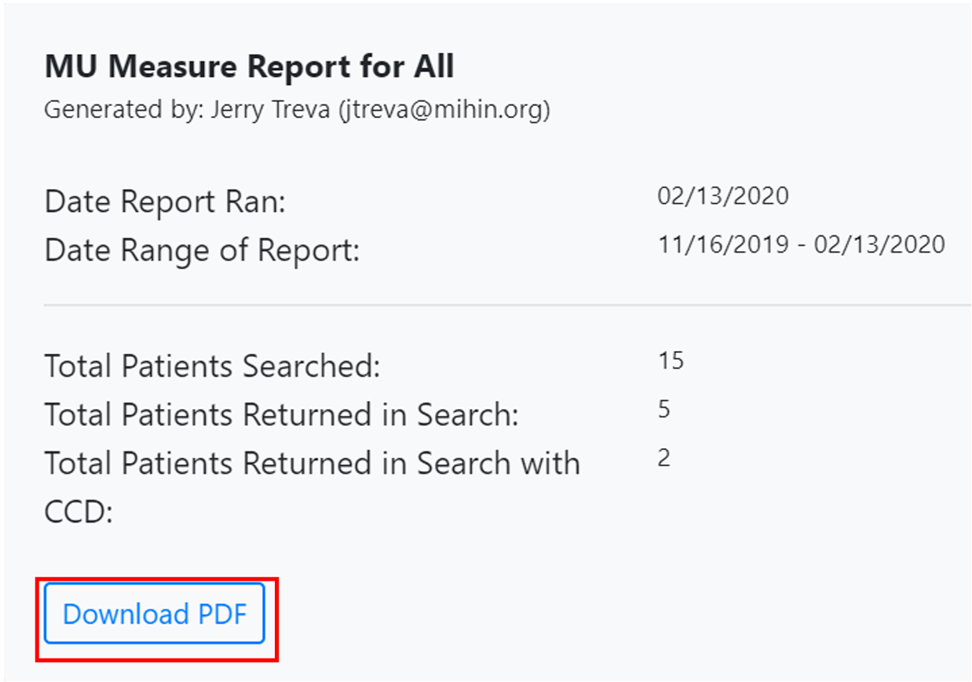
Figure 94. Download PDF of Meaningful Use Patient Search Measurement Report

3.5 Diretto
MiHIN’s Health Information Service Provider (HISP), Diretto, makes sending direct secure messages containing patient Protected Health Information (PHI) quick, easy, and efficient.
To request a Diretto account, submit a Help Desk ticket (Product Support>Diretto/DSM).
To access Diretto, click on the Inbox menu item and select Diretto Inbox as shown in Figure 95.
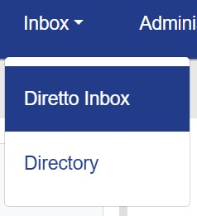
Figure 95. Diretto Menu Option
The login screen is shown in Figure 96. Users must enter credentials for their Diretto account.
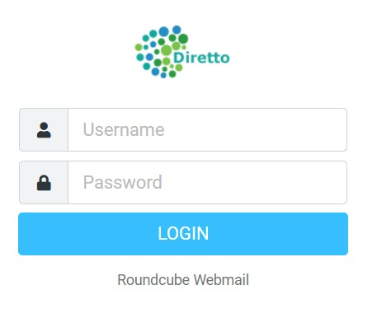
Figure 96. Diretto Login Screen

3.5.1 Diretto Interface
Once logged in, the user will be taken to the main mailbox page, as shown in Figure 97.
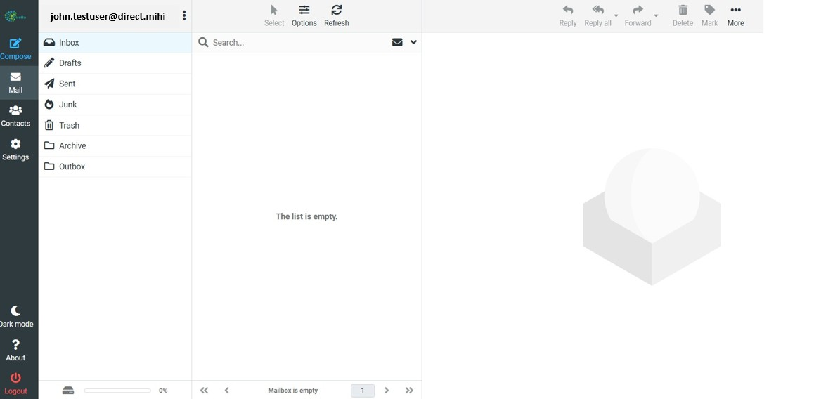
Figure 97. Diretto Email Interface
The Mail layout is similar to other email systems with the following folders:
- Inbox – Location of all incoming messages
- Drafts – You can save any in progress messages in this folder
- Archive – Location where older messages are stored.
- Trash – Items deleted out of any of the other folders will be placed in this folder. From here, they can either be restored to their original folder or deleted permanently.
- Junk – Location of unwanted messages sent from unrecognized sources
- Sent Items – Location of all sent messages

3.5.1.1 Compose Email
Click the Compose button in the left-hand bar to compose and send a new email, as shown in Figure 98. Please note that you can only send to other Direct secure email addresses. You can add attachments to an email and select sending options in the right-hand bar of the message window.
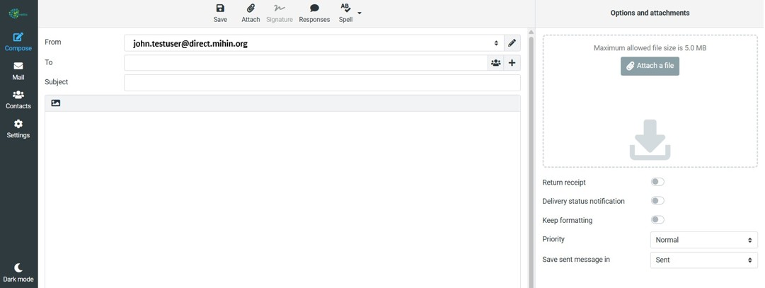
Figure 98 Compose Email screen
Click on the Settings button in the left-hand bar to customize various settings as shown in Figure 99.
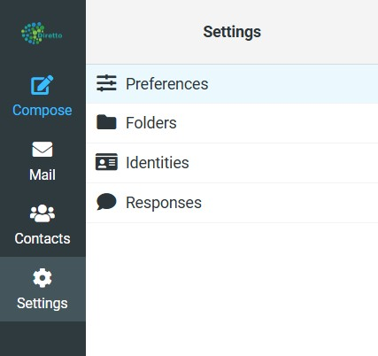
Figure 99. Diretto Email Settings
- Preferences – This setting provides multiple options to customize your message display, inbox interface, composing messages, etc.
- Folders – This setting allows you to toggle on and off certain folders from being displayed in your Mail, as shown in section 2 of Figure 100 below. The toggle will be a slightly darker blue if you are allowed to toggle on/off that folder. You can also create new custom folders when you click the Create button in the upper right-hand section of the page as shown in section 3 of Figure 100:
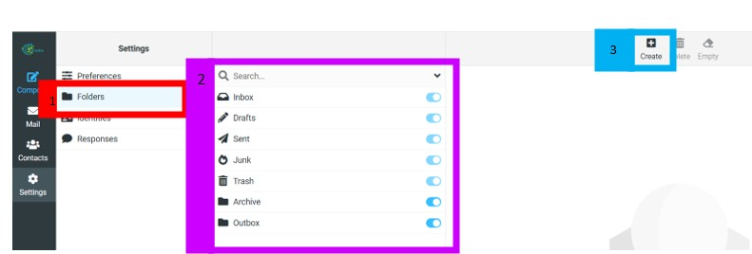
Figure 100. Create Customer Folders
- Identities – This setting will show your Direct email address.
- Responses – This setting allows you to create custom standard responses that you may use frequently to easily insert into an email. Click the Create button in the upper right-hand corner of the screen and it will allow you to name the response and then enter the response text.
When composing an email, put your cursor in the body of the email where you want to insert the standard response, then click the Responses button and select the appropriate response from the drop-down list.
For more information on Diretto, visit https://mihin.org/ diretto/.

3.5.2 Diretto Directory Interface
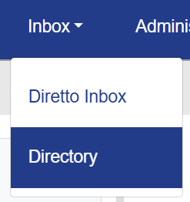
The Directory menu option allows Diretto users to search the national DirectTrust aggregated Directory for direct secure messaging users. The Directory is accessed within MIGateway under the Inbox menu, as shown in Figure 101.
Figure 101. Diretto Directory Menu Option
After clicking the Directory option, the Directory Search screen will open as shown in Figure 102.
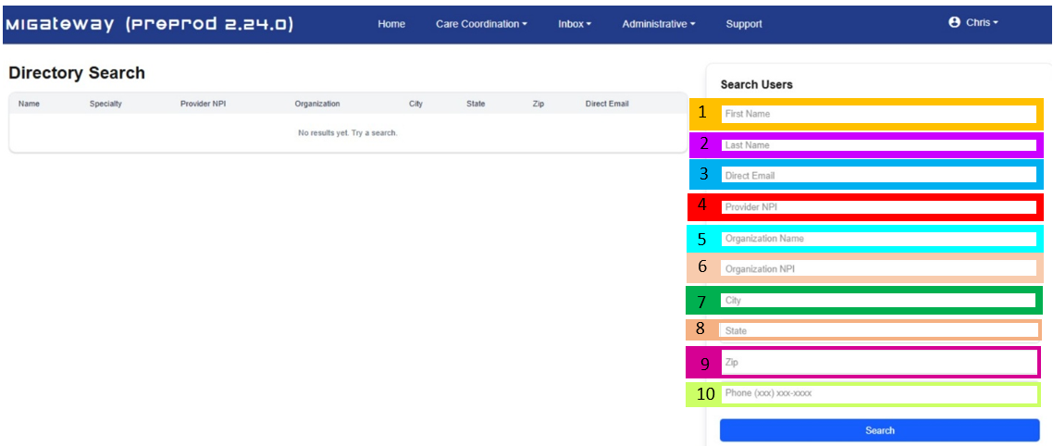
Figure 102. Diretto Directory Search Screen
The available search fields are listed on the right-hand side of the screen.
1 | First Name: Enter the provider’s first name. A minimum of two characters is required.
2 | Last Name: Enter the provider’s last name. A minimum of two characters is required.
3 | Direct Email: Enter the provider’s entire direct email address.
4 | Provider NPI: Enter the provider’s entire NPI number.
5 | Organization Name: Enter the name of the organization. This field allows the user to enter a partial name and it will return all entries that match the partial name criteria.
6 | Organization NPI: Enter the organization’s entire NPI number.
7 | City: Enter the entire city name in which the organization is located.
8 | State: Enter the two character state abbreviation (not the full state name, it will only search on the abbreviations) in which the organization is located.
9 | Zip: Enter the zip code in which the organization is located.
10 | Phone: Enter the full phone number of the organization. Enter it exactly as shown in the example, with the area code in parentheses followed by a space and the full phone number including the dash.
Once you’ve entered the search criteria, click the Search button at the bottom of the page, as shown in Figure 103. The Search button will turn gray while it is searching.

Figure 103. Directory Search button
The search results will display on the lefthand side of the screen, as shown in Figure 104. The directory will display up to 100 results. If more than 100 results match the search criteria entered, only the first 100 results will be displayed, and you may wish to enter additional criteria to narrow down the search.
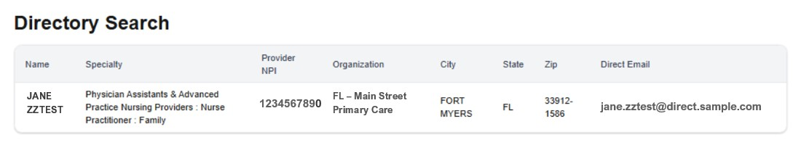
Figure 104. Directory Search Results Display
Detailed Results
You can view additional information for a result by clicking anywhere in the result display for that user account. (The display area will turn a light gray when you hover your mouse over it.) A pop-up screen with additional information will appear, as shown in Figure 105.
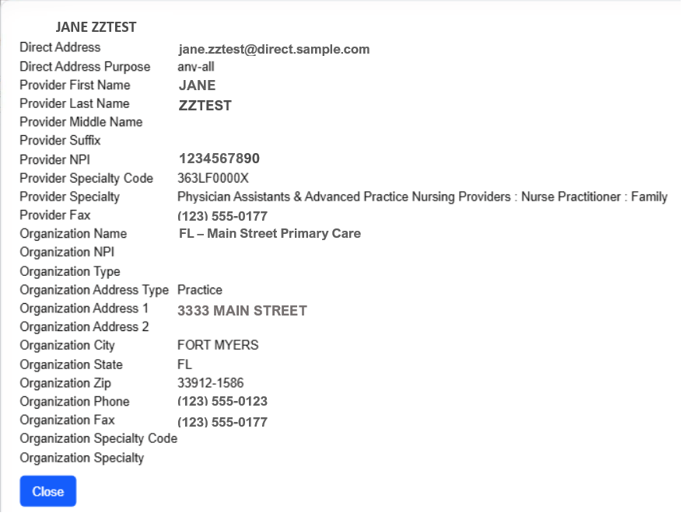
Figure 105. Directory Search Results – Screen with Entire Data
Click the Close button when done reviewing the data.
Note 1: If there are any empty fields in the results data, as shown in the example above, the data is not available within the directory.
Note 2: For the Organization Name field, DirectTrust has prefixed the name with the state abbreviation, as shown in the examples above.
No Results
If there are no results that match the search criteria you entered, the message “No records found. Try a different search.” will display in the results area as shown in Figure 106.
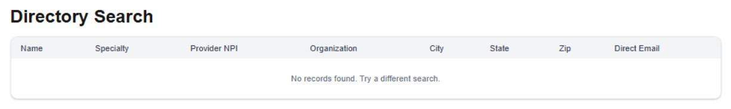 Figure 106. No Records Found message.
To do another search, or to correct a search entry, manually remove the current data in the Search fields and enter the new search criteria.

3.6 Longitudinal Patient Record
The Longitudinal Patient Record is a comprehensive patient record comprised of data from several ACRS® Populations across the healthcare continuum. It is designed to be one record per patient by using comprehensive patient matching logic wrapped in a consent management model. The Longitudinal Patient Record module provides an interface for users to access this patient record in a convenient and digestible manner and provides tools to work with the data displayed. This module allows users to:
- Access clinical data efficiently, including data needed for:
  - Treatment
  - Payment
  - Operations
  - Public Health
  - Federal Programs
  - Individual Authorizations
- Provides information needed for resolution of:
  - Care Coordination
  - Population Health Management
  - Medication Management
  - Clinical Decision Support

3.6.1 Longitudinal Record UI Elements
The Longitudinal Record is accessed via the Patient Viewer described in more detail in section 3.3. A user can access the Longitudinal Record in the Patient Summary view by clicking the gray “Longitudinal Patient Record” button located in the lower right corner, as shown in Figure 107.
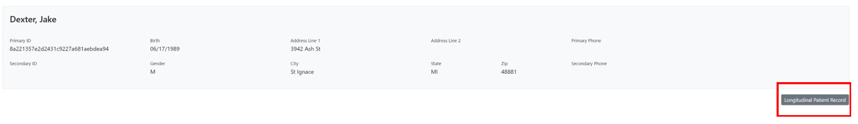
The resulting screen will display the Longitudinal Record for the selected patient. This view has sections and UI elements that display a wide range of information about the patient and their summary of care. These are broken into the following sections:
Figure 107. Longitudinal Record Access via Patient Viewer

3.6.1.1 General Setting UI Elements
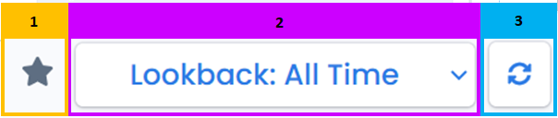
There are several UI elements on the main Longitudinal Record page, which are designed to allow the user to better define and work with the information provided throughout the rest of the page as shown in Figures 108 and 109
Figure 108. General Longitudinal Record UI
1 | “Star”: Currently, the star toggle does not have a function. It may serve as a way to favorite and create shortcuts to specific records, but at this point, it is unusable.
2 | Lookback: Drop-down menu that allows a user to define the period they would like information on the patient for in the following increments:  - All Time  - 12 Months  - 6 Months  - 5 Years
3 | Refresh: Refreshes the Patient Summary page, considering any changes to the specified period
Figure 109. LR General UI Element Descriptions

3.6.1.2 Patient Information
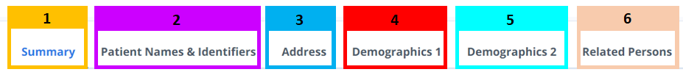
The patient information section of the Longitudinal Record displays individual details about the patient, including name, identifiers, demographics, and address information. These details are organized into a series of tabs as shown in Figures 110 and 111.
Figure 110. Patient Summary – Patient Information Headers
1 | Summary: Displays a summary of the basic patient information included in all other tabs, including:  - Patient Information  - EID  - First Name  - Middle Name  - Last Name  - Demographics  - Date of Birth in the format: YYYY-MM-DD  - Gender  - Marital Status  - Deceased  - Contact Information  - Email  - Phone  - Address in the format: Street Number, Street Name, City, State, Zip Code
2 | Patient Names & Identifiers: Displays all unique identifiers (both primary and secondary), as well as any names attributed to the patient in the following sections:  - Primary IDs  - Source  - Patient ID  - Secondary IDs  - Source  - Value  - Type  - Names  - First – All first names attributed to patient  - Last – All last names attributed to patient  - Last Updated – The last date that the patient’s name was updated in the format of YYYY-MM-DD
3 | Address: Displays address information for the patient, including the following information:  - Source – The source the address information was pulled from  - Address Line 1 – Street number and name  - Address Line 2 – Apt/Unit Number or P.O. Box  - City  - State  - Postal – 5 Digits  - Last Updated – The last date that the patient’s address was updated in the format: YYYY-MM-DD
4 | Demographics 1: Displays additional demographic information for the patient, including the following:  - Language  - Language  - Preferred Status: True or False  - Source  - Last Updated – The last date that the patient’s language was updated in the format: YYYY-MM-DD  - Religion  - Religion  - Source  - Last Updated – The Last date that the patient’s religion was update in the format: YYYY-MM-DD  - Citizenship
5 | Demographics 2: Displays additional demographic information for the patient, including the following:  - Birthplace  - Race  - Ethnicity
6 | Related Persons: Displays a list of individuals related to the patient
Figure 111. Patient Summary - Patient Information Header Descriptions

3.6.1.3 Problems
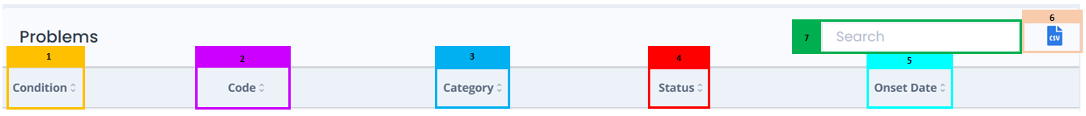
This section lists diagnosed health issues and conditions recorded for the patient. It may include chronic illnesses, past medical conditions, or newly diagnosed problems. This is used to quickly understand the patient’s medical history and current health concerns. This section and its headers are shown in Figures 112 and 113.
Figure 112. Problems Section Headers
1 | Condition: Lists the name of a clinical condition, problem, diagnosis, or other event, situation, issue, or clinical concept that has risen to a level of concern
2 | Code: Code associated with the identification of the condition, problem, or diagnosis. This is a comma-delimited list and can include, but is not limited to the following:  - SNOMED  - ICD-10
3 | Category: Displays the category assigned to the condition. It is contextual based on a provider’s list of category types.  - Problem List Item – An item on a problem list that can be managed over time and can be expressed by a practitioner (e.g., physician, nurse), patient, or related person  - Encounter Diagnosis – A point in time diagnosis (e.g., from a physician or nurse) in context of an encounter
4 | Status: Displays the status of the listed problem from the following:  - Active  - Inactive
5 | Onset Date: Estimated date, actual date, or date-time the condition, situation, or concern began in the opinion of the clinician: MM/DD/YYYY
6 | CSV Icon: Creates and downloads a .csv file with information listed in this section for the patient.
7 | Search: Filters list of all problems and devices on the entered terms
Figure 113. Problems Section Header Descriptions

3.6.1.4 Medication Orders and Requests
The Medication Orders and Requests section shows medications that have been prescribed or recommended for a patient by a healthcare provider. These may include active prescriptions, past orders, or instructions shared between providers and care teams. This section should be used when you need to review what a provider intended the patient to take—whether it’s a current prescription, something planned, or even a discontinued medication order. The information in this section is detailed in Figures 114 and 115.
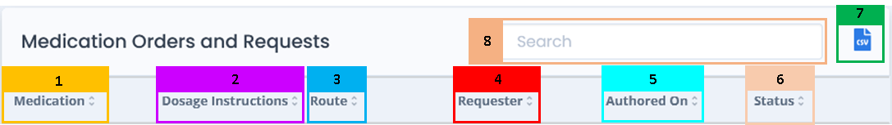
Figure 114. Medication Orders and Requests Headers and UI Elements
1 | Medication: Displays the name and type of the medication ordered/requested
2 | Dosage Instructions: Displays instructions for the listed medications, including method and frequency of administration
3 | Route: Displays the method of intake for the listed medication. May include, but is not limited to the following:  - Oral  - Topical  - Inhalation  - Intravenous
4 | Requester: Displays the name of the care provider requesting the medication order
5 | Authored On: Displays the date that the medication order and/or request was written in the format: M/DD/YYYY
6 | Status: Displays the status of the ordered medication with the listed patient. Field may include, but is not limited to the following examples:  - Active  - Stopped
7 | CSV Icon: Creates and downloads a .csv file with information listed in this section for the patient.
8 | Search: Filters list of all medication orders and requests on the entered terms
Figure 115. Medication Orders and Requests Headers and UI Element Descriptions

3.6.1.5 Medication Statements
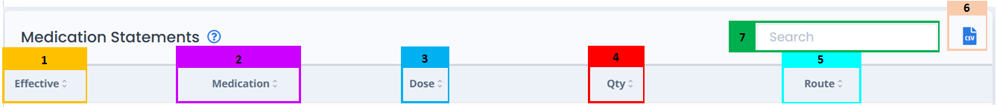
The Medication Statements section lists information regarding the details and status of active medications prescribed to the patient and allows for searches to filter the list for specific information. The information in this section is detailed in Figures 116 and 117.
Figure 116. Medication Statements Headers and UI Elements
1 | Effective: Displays the date upon which the listed mediation was first effective in the format: MM/DD/YYYY
2 | Medication: Displays the name and the measurement per dosage of the listed medication
3 | Dose: Displays the number of dosages to be administered for the listed medication. The unit of measurement within a singular dose is listed in the next section.
4 | Quantity: Displays the unit of measurement used to measure a dosage of the listed medications listed in formats including but not limited to the following:  - Mg  - Ug  - {tbl}  - mL/h
5 | Route: Displays the method of intake for the listed medication from the following:  - Oral  - Topical  - Inhalation  - Intravenous
6 | CSV Icon: Creates and downloads a .csv file with information listed in this section for the patient.
7 | Search: Filters list of all medication orders and requests on the entered terms
Figure 117. Medication Statements Header and UI Element Descriptions

3.6.1.6 Procedure/Devices
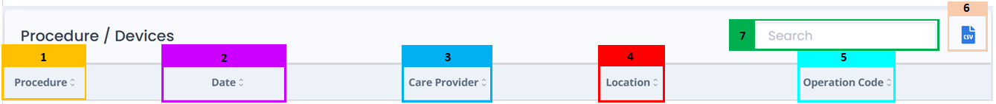
This Procedure/Devices section displays surgeries, treatments, and medical devices the patient has received or is using. This includes procedures like a knee replacement or the insertion of a pacemaker. This section is helpful for reviewing a patient’s surgical history or device use across different visits. The information detailed in this section is described in Figures 118 and 119.
Figure 118. Procedure/Devices Headers and UI Elements
1 | Procedure: Displays the action that is being or was performed on an individual
2 | Date: Displays the date of the given procedure in the format: MM/DD/YYYY
3 | Care Provider: Displays the name of the provider that performed the listed procedure in the format: Last Name, First Name
4 | Location: Displays the location where the procedure was performed
5 | Operation Code: Displays the procedure’s number identification, as defined by the associated code set in the format: 00000; A0; A00
6 | CSV Icon: Creates and downloads a .csv file with information listed in this section for the patient.
7 | Search: Filters list of all listed procedures based on the information entered
Figure 119. Procedure/Devices Header and UI Elements Descriptions

3.6.1.7 Immunizations
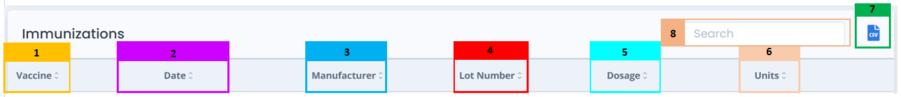
The Immunizations section shows a record of vaccines administered to the patient. This may include childhood immunizations, flu shots, COVID-19 vaccines, and others. This section is used to verify a patient’s vaccination status or identify any gaps in immunization history. The details of this section are described in Figures 120 and 121.
Figure 120. Immunizations Headers and UI Elements
1 | Vaccine: Displays the vaccine product administered
2 | Date: Displays the date on which the listed vaccination was administered in the format: MM/DD/YYYY
3 | Manufacturer: Displays the name of the organization that administered the listed vaccine
4 | Lot Number: Displays the identifying code representing the lot number for the listed vaccine in the format: 0123L45A
5 | Dosage: Displays the amount of the vaccine administered. Value is a number value. The unit of measurement that applies to this is listed in the following section
6 | Units: Displays the units of measurement of the vaccine administered including, but not limited to the following:  - mL
7 | CSV Icon: Creates and downloads a .csv file with information listed in this section for the patient.
8 | Search: Filters list of all listed immunizations based on the information entered
Figure 121. Immunizations Header and UI Element Descriptions

3.6.1.8 Encounters
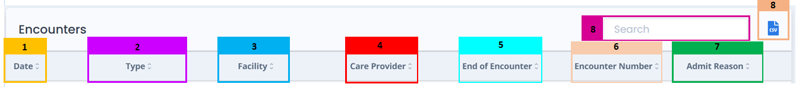
The Encounters section Lists past visits to healthcare facilities, including office visits, hospital stays, and emergency room visits. This can be useful for tracking where and when a patient received care, along with the reason for the visit. The details of this section are described in Figures 122 and 123.
Figure 122. Encounters Headers and UI Elements
1 | Date: Displays the start date of the encounter in the format: MM/DD/YYYY
2 | Type: Displays the specific type of encounter. Due to the substantial number of encounters, it is not possible to have a list of values.
3 | Facility: Displays the name of the facility where the encounter occurred
4 | Care Provider: Displays the service provider that managed the encounter in the following format: Last Name, First Name
5 | End of Encounter: Displays the concluding date of the encounter in the format: MM/DD/YYYY
6 | Encounter Number: Displays the number assigned to the encounter by the care provider in the format: 00000 (May include more digits)
7 | Admit Reason: Displays the reason the patient was admitted. This is a free text field and will reflect what reasons were entered.
8 | CSV Icon: Creates and downloads a .csv file with information listed in this section for the patient.
9 | Search: Filters list of all listed encounter entries based on the information entered
Figure 123. Encounter Header and UI Element Descriptions

3.6.1.9 Allergies
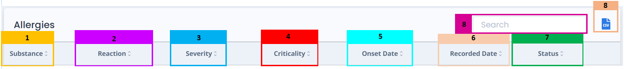
The Allergies section Displays any known allergies or intolerances, such as reactions to medications, foods, or environmental triggers. This is critical for ensuring safe treatment and avoiding allergic reactions. The details in the section are described in Figures 124 and 125.
Figure 124. Allergies Headers and UI Elements
1 | Substance: Lists the substance the patient has an allergy to taken from a value set of substances
2 | Reaction: Describes the clinical symptoms/signs associated with the substance exposure event
3 | Severity: Lists the severity of the reaction associated with the substance exposure event from the following options:  - Mild  - Moderate  - Severe
4 | Criticality: Describes the impact of the allergic reaction regarding the need to treat the reaction of the associated exposure event from the following:  - Low  - High  - Unable-to-Assess
5 | Onset Date: Lists the date of the last known occurrence of a reaction in the format: MM/DD/YYYY
6 | Recorded Date: Lists the date the occurrence of a reaction was recorded by provider in the format: MM/DD/YYYY
7 | Status: Lists the status of the patient in relation to the substance exposure event from the following:  - Active  - Recurrence  - Relapse  - Inactive  - Remission  - Resolved  - Unknown
8 | CSV Icon: Creates and downloads a .csv file with information listed in this section for the patient.
9 | Search: Filters list of all allergy entries based on the information entered
Figure 125. Allergies Header and UI Element Descriptions

3.6.1.10 Insurance
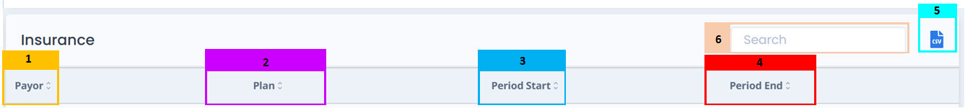
The Insurance Provides details about the patient’s health insurance coverage, including plan names and policy information when available. This section is used to confirm eligibility and understand potential coverage for care or medications. The details of this section are described in Figures 126 and 127.
Figure 126. Insurance Headers and UI Elements
1 | Payor: Displays the name of the organization providing coverage for the listed patient
2 | Plan: Displays information about the plan the patient is covered by including:
3 | Period Start: Displays the insurance plan’s start date in the format: MM/DD/YYYY
4 | Period End: Displays the insurance plan’s end date in the format: MM/DD/YYYY
5 | CSV Icon: Creates and downloads a .csv file with information listed in this section for the patient.
6 | Search: Filters list of all Coverage entries based on the information entered
Figure 127. Insurance Header and UI Element Descriptions

3.6.1.11 Diagnostic Imaging
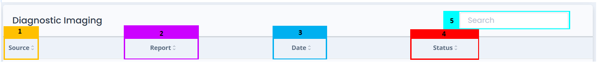
The Diagnostic Imaging section shows radiology reports from imaging studies like X-rays, CT scans, MRIs, or ultrasounds. The focus here is on written findings, not the images themselves. This section is used to review how radiologists interpreted the imaging. The details of this section are described in Figures 128 and 129.
Figure 128. Diagnostic Imaging Headers and UI Elements
1 | Source: Displays the facility from which the listed imaging report came from
2 | Report: Displays the name and type of report performed on the listed patient
3 | Date: Displays the clinically relevant date for the report in the format: DD/MM/YYYY
4 | Status: Displays the diagnostic status of the listed diagnostic report. Values can include, but are not limited to the following:  - Unknown  - Final
5 | Search: Filters list of all Diagnostic Report entries based on the information entered
* | Please Note: Each entry in this section includes a which can be clicked to expand or collapse the row, revealing more information about the individual tests performed in any listed lab and can further describe the reason for any Flagged results
Figure 129. Diagnostic Imaging Header and UI Element Descriptions

3.6.1.12 Other Results
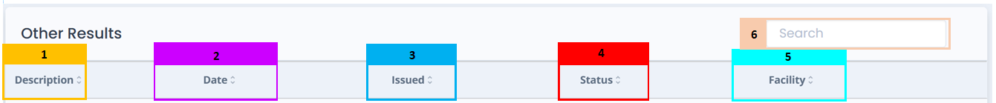
The Other Results section covers specialized tests and reports that do not fall under standard lab results. Examples include pathology reports, tissue biopsies, ECGs, and EKGs. Check this section for advanced diagnostic findings that require clinical interpretation. The details included in this section are described in Figures 130 and 131.
Figure 130. Other Results Headers and UI Elements
1 | Description: Displays a description of the test, exam or report conducted for the listed patient.
2 | Date: Displays the date the tests that the results came from was performed in the format: DD/MM/YYYY
3 | Issued: Displays the date results were issued to the patient in the format: DD/MM/YYYY
4 | Status: Displays the status of the results. Includes, but is not limited to the following:  - Final
5 | Facility: Displays the name of the facility that the testing and the corresponding results came from
6 | Search: Filters list of all Laboratory entries based on the information entered
* | Please Note: Each entry in this section includes a which can be clicked to expand or collapse the row, revealing more information about the individual tests performed in any listed lab and can further describe the reason for any Flagged results
Figure 131. Other Results Header and UI Elements Descriptions

3.6.1.13 Lab/Observation Results
The Lab/Observation Results section shows results from routine lab tests such as blood work, urine tests, or metabolic panels. This section is used to monitor trends in patient health over time or evaluate recent lab findings.

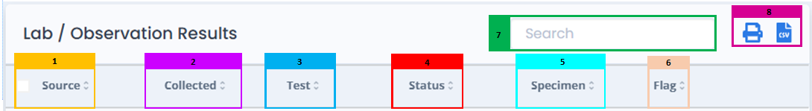
Note – Observation Results from CCD data (Lab, Diagnostic, Other) will also appear on the Lab Results widget at this time. The details included in this section are described in Figures 132 and 133.
Figure 132. Laboratories Headers and UI Elements
1 | Source: Displays the name of the facility that the lab or observation was performed and produced from
2 | Collected: Displays the date the lab or observation was performed in the format: DD/MM/YYYY HH:MM
3 | Test: Displays the type of test that was performed. May include the medium of the test and what was being tested for
4 | Status: Displays the status of the performed test. Includes, but is not limited to the following:  - Final
5 | Specimen: Displays a symbol to flag healthcare providers associated with the listed lab result, indicating that they would benefit from the additional information included in the expanded view. This view is described below.
6 | Flag: Displays a symbol to flag healthcare providers associated with the listed lab result, indicating that they would benefit from the additional information included in the expanded view. This view is described below.
7 | Search: Filters list of all Laboratory entries based on the information entered
8 | CSV Icon: Exports the selected lab result entries as a .csv file, including all information included in the entries drop down menu.  Print Icon: Exports the selected lab result entry as a .pdf file, including all information included in the entry’s drop down menu, for download or print.
* | Please Note: Each entry in this section includes a which can be clicked to expand or collapse the row, revealing more information about the individual tests performed in any listed lab and can further describe the reason for any Flagged results
Figure 133. Laboratories Header and UI Element Descriptions

3.6.1.14 Documents/Clinical Notes
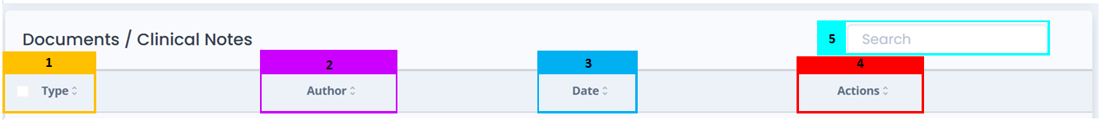
The Documents/Clinical Notes section Includes clinical summaries, visit notes, discharge summaries, and other provider-written documentation. The information included in this section is described in Figures 134 and 135.
Figure 134. Documents/Clinical Notes Headers and UI Elements
1 | Type: Lists the type of document from a comprehensive value set
2 | Author: Lists the name of the Source Organization that document, or clinical notes were received from.
3 | Date: Displays the date the document or clinical note was created in the format: DD/MM/YYYY
4 | Actions: Displays actions that the user can take with this listed document include the following:  -  View – Opens a copy of the listed document for the user to view  -  Download – Downloads a copy of the listed document into the user’s local system
5 | Search: Filters list of all Documents and Clinical Note entries based on the information entered
Figure 135. Documents/Clinical Notes Header and UI Element Descriptions

3.6.1.15 Vital Signs
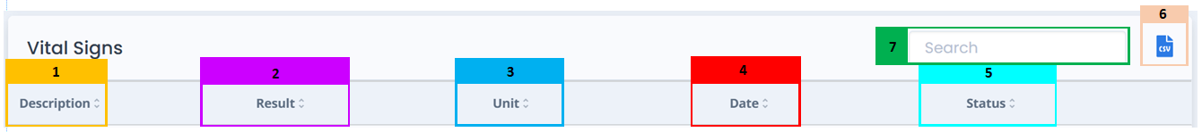
The Vital Signs section displays basic health measurements like blood pressure, heart rate, temperature, weight, and oxygen levels. This information is essential for monitoring current health status and tracking changes over time. The details included in this section are described in Figures 136 and 137.
Figure 136. Vital Signs Headers and UI Elements
1 | Description: Displays the description of the vital sign measured such as:  - Heart Rate  - Respiratory Rate  - Height  - Weight  - Temperature  - Systolic blood pressure  - Diastolic blood pressure
2 | Result: Displays the numeric value of the measured vital sign
3 | Unit: Displays the represented unit that applies to the listed vital sign
4 | Date: Displays the date the listed vital signs were taken in the format: DD/MM/YYYY HH:MM
5 | Status: Displays the status of the listed vital sign values from the following:  - Registered  - Preliminary  - Final  - Amended  - Corrected  - Cancelled  - Entered-in-Error  - Unknown
6 | CSV Icon: Creates and downloads a .csv file with information listed in this section for the patient.
7 | Search: Filters list of all Laboratory entries based on the information entered
Figure 137. Vital Signs Header and UI Element Descriptions

3.6.2 Getting Started with Longitudinal Patient Record

3.6.2.1 Customizing the Longitudinal Record
By default, a patient’s Longitudinal Record will default to displaying records and information as far back as is possible. Users can change this period by clicking the “Lookback” button and selecting a different time range and clicking the refresh button, as shown in Figure 138.
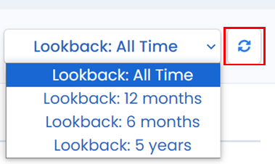
Once the page refreshes, entries for all sections of the patient’s Longitudinal Record will now display data only for the specified range.
Figure 138. Lookback Dropdown Menu Options and Refresh Button

3.6.2.2 Viewing and Downloading Patient Documents and Information
The Longitudinal Record module offers several methods for users to view patient summary information and documents associated with the patient’s care coordination.
Creating .CSV Files
For any of the Longitudinal Record sections displayed for a patient, the listed information can be exported to a .csv format if applicable.
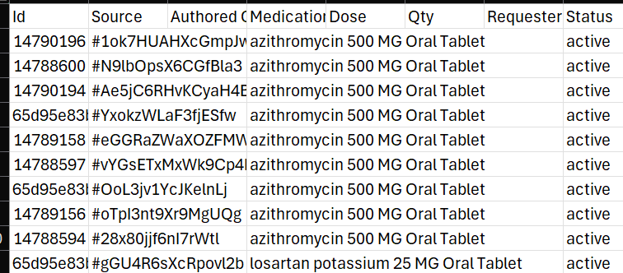
In any of the sections, clicking the “CSV”  icon will download the displayed information in .csv format to the user’s computer. An example of this file is shown in Figure 139
Figure 139. Exported .CSV File Example
Creating PDFs with Patient Header for Lab and Observation Results
Figure 139. Exported .CSV File Example
In the La/Observation Results section, users may also export and view selected lab results in PDF format. This is accomplished by selecting the desired lab result(s) via the checkbox in the left-most column, and then selecting the icon, as shown in Figure 140.
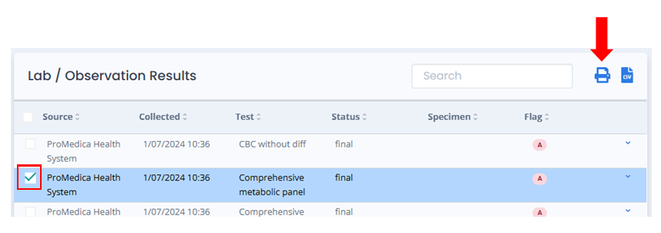
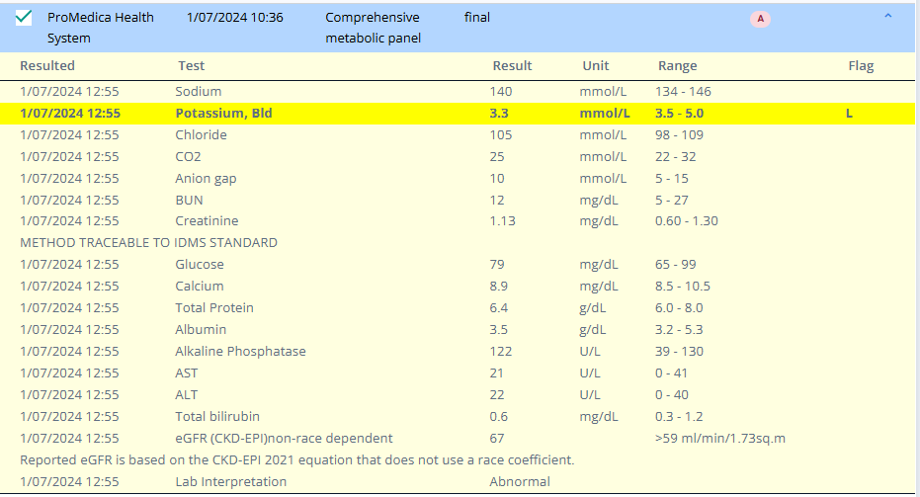
Once selected, a PDF will be generated and displayed. How this occurs will vary depending on the user’s browser, available applications and settings. The information included in the PDF includes all information in the lab result entry, including all information in the drop-down menu as is shown in Figures 141a and 141b.
Figure 141a. Lab Result Entry Including Sub-Menu Information
Figure 140. Selection Checkbox and PDF Export Button Location

The PDF presents the result(s) in a human-readable format and includes the patient demographic header from the Longitudinal Record.
One or more results may be selected using the checkbox next to the result. If multiple results are selected, they will be combined into a single PDF. If no result is selected, an error message will instruct the user to select one or more rows.
Viewing Documents/Clinical Notes and Diagnostic Imaging
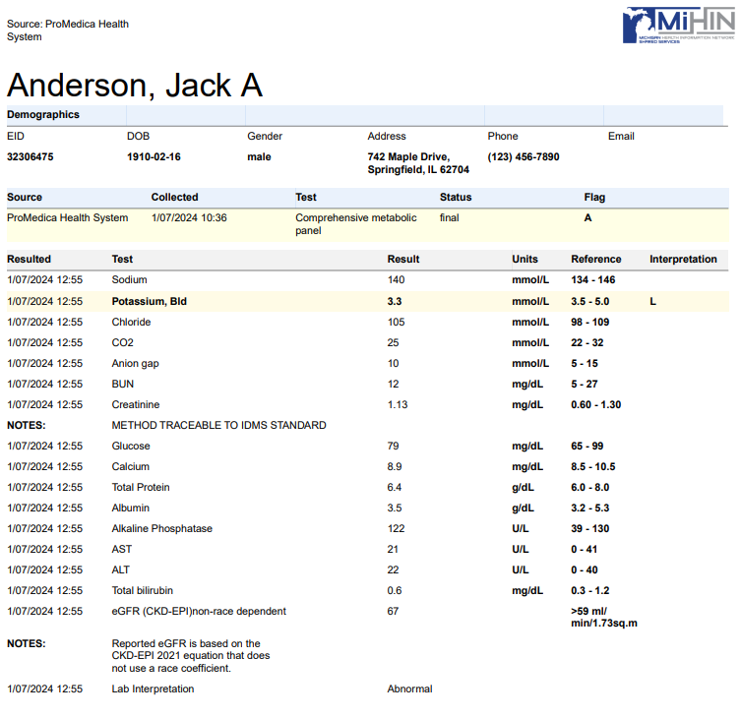
In the Documents/Clinical Notes and Diagnostic Imaging sections of the Longitudinal Record, users click the “View”  icon to open the full document in another tab on their internet browser.
Figure 141b. PDF Produced from the Lab Entry Shown in Figure 141a
In addition to viewing clinical documents and notes, users can download and export the documents by clicking the “Download”  icon. This will save the associated document to the user’s computer in the file’s applicable format.

3.7 Provider Results Viewer
The Provider Results Viewer (PRV) is a tool which functions like an email inbox and is accessed via MIGateway to receive patient diagnostic and results information. ADT, lab, radiology, and transcription messages are sent in real time to the PRV. Consolidating this data within a single viewer offers a convenient way to manage it from a single location, as well as streamline into existing workflows for increased efficiency.
The PRV is designed for easy navigation, allowing users to customize their message display through multiple search and filter capabilities. Furthermore, a pdf report of every message is available, including the ability to download them individually or in bulk.

3.7.1 Provider Results Viewer UI Elements
Users that have the Provider Results Viewer configured during their MIGateway onboarding can access the Patient Results Viewer once logged in.
Once on the Patient Viewer landing page, the user can access the Provider Results Viewer by hovering over the Care Coordination tab and clicking on the Provider Results Viewer as shown in Figure 142.
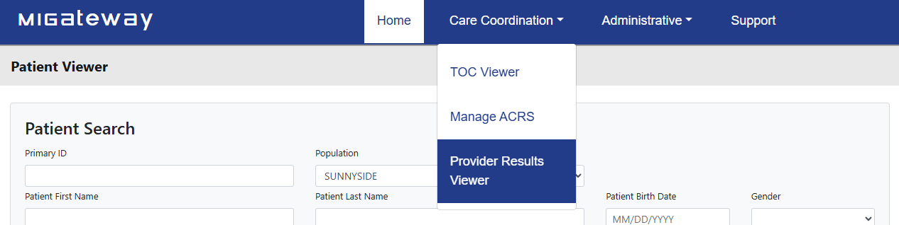
From here, the user should find themselves on the Inbox page on the resulting screen, as shown in Figure 143.
Figure 142. Provider Results Viewer Navigation
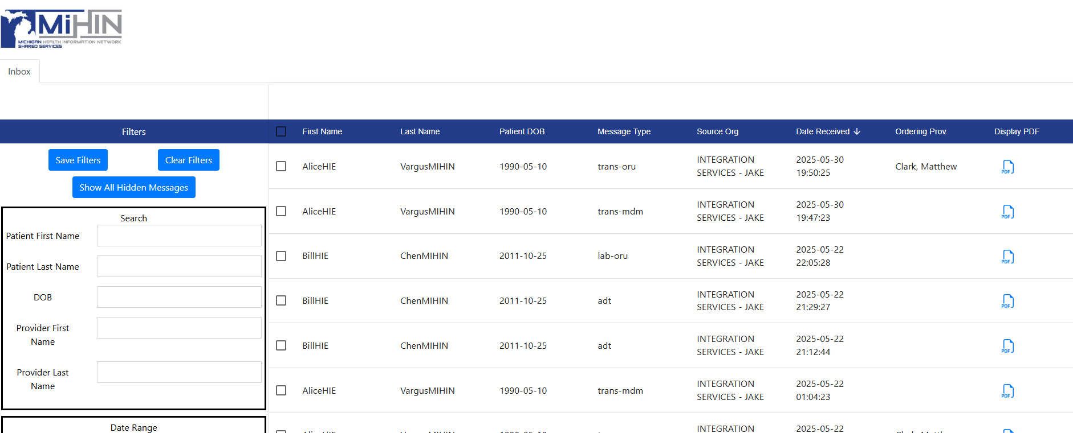
The Provider Results Viewer interface is broken up into two main components:
Figure 143. Provider Results Viewer Inbox Page
- Filters – can be used to search and filter patients and their associated messages based on the information entered
- Resulting Patient – the columns that list information regarding all messages that meet the current search criteria
The following sections will cover each in further detail.

3.7.1.1 Provider Results Viewer Filters
The PRV Filters allow users to search based on Patient or Provider information, Date Range, Message Type and Provider NPI. A view of all available elements and their descriptions can be found in Figures 144a, 144b and 145.

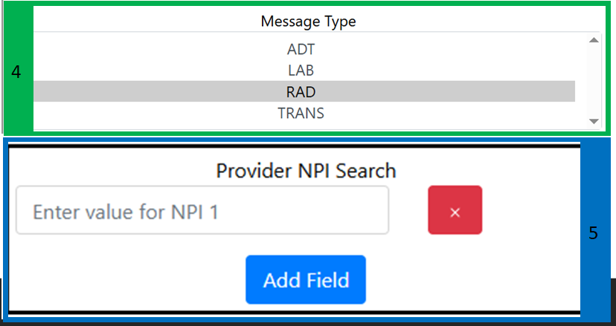
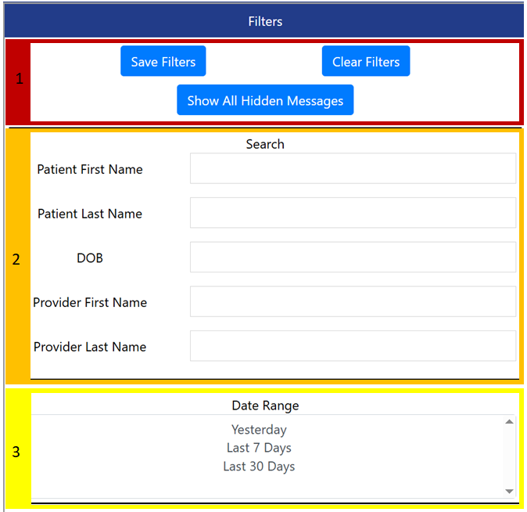
Figure 144b. Filters User Interface
Figure 144a. Filters User Interface
1 | Filter Option Buttons – Displays buttons that can be used to update the filter search as a whole, including:  - Save Filters – Saves the current filter setting for future use  - Clear Filters – Clears all entered and selected information and resets the view in the Resulting Patients Field  - Show All Hidden Messages – Displays messages that are currently being hidden from the Resulting Patients Field results  - Serves to view messages filtered out of the field without clearing the search filters
2 | Search Criteria -Fields that can be populated with information to filter the list of displayed patients and their corresponding messages and documents. Includes:  - Patient First Name – Filters list to include only entries with the listed first name of the patient  - Patient Last Name – Filters list to include only entries with the listed last name of the patient  - Date of Birth (DOB) – Filters list to include only entries with listed date of birth of the patient  - Provider First Name – Filters list to include only entries with the listed first name of providers associated with the message  - Provider Last Name Filters list to include only entries with the listed last name of providers associated with the message
3 | Date Range – Filters displayed entries to only include those that fall within a specified period from the following:  - Yesterday  - Last 7 days  - Last 30 days
4 | Message Type – Filters displayed entries to only include those of a specified message type, including:  - ADT  - Lab  - Rad  - Trans
5 | Provider NPI Search – Filters displayed entries to only show those that contain the entered NPI number. Allows for the addition of NPI entries by clicking on the  button
Figure 145. Filters User Interface Descriptions

3.7.1.2 Provider Results Viewer Resulting Patients Field
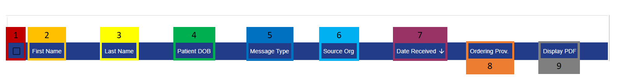
The Resulting Patients Field displays a series of columns that show information about the patient and types of messages and documents associated with them. Additionally, it also provides a way of viewing the documents. A view of each of the column UI elements and their descriptions can be found in Figures 146 and 147.
Figure 146. Resulting Patients User Interface
1 | Select All Box – Allows for the selection and download of PDFs for all listed entries. Clicking this box will check the corresponding box in this column for every entry.
2 | First Name – Lists the first Name of the patient for any entry.
3 | Last Name – Lists the last name of the patient for any entry
4 | Patient Date of Birth (DOB) – Lists the date of birth of the patient for any entry in the following format: YYYY-MM-DD
5 | Message Type – Shows the type of message associated with the patient for any entry from the following:  - trans-mdm  - trans-oru  - rad-oru  - lab-oru  - ADT
6 | Source Organization – Lists the organization or facility that the listed message/document for the patient originated from
7 | Date Received – Lists the date and time that the message/document was received by the receiving provider in the format: YYYY:MM:DD:HH:MM:SS
8 | Ordering Provider – Lists the name of the provider that ordered the lab/document listed in the entry in the format: Last Name, First Name
9 | Display PDF – Includes a link to the document/message in question. Clicking the icon will open the associated message/document in a new page.
Figure 147. Resulting Patients User Interface Descriptions

3.7.2 Using the Provider Results Viewer

3.7.2.1 Searching for Provider Results
The Filter user interface allows Provider Results Viewer users to define any number of key terms and search criteria to filter their results to only include that combination of search parameters. The list of results is updated as criteria is entered into any of the fields as shown in Figure 148.
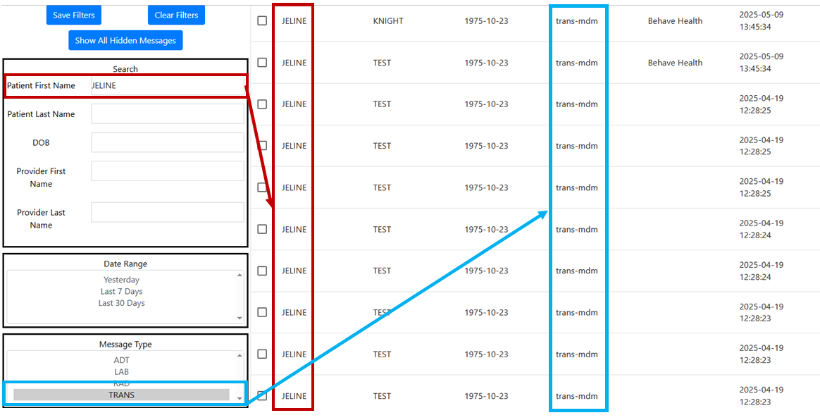
3.7.2.2 Viewing Provider Results
Figure 148. Provider Results when Criteria has Been Entered for First Name and Message Type
The Provider Results Viewer also offers the ability to open and view a full report of the listed message and patient. This is accomplished by navigating to the desired entry and clicking the icon in the last column.
Once clicked, a new page opens displaying the desired information in PDF format like that displayed in Figure 149.
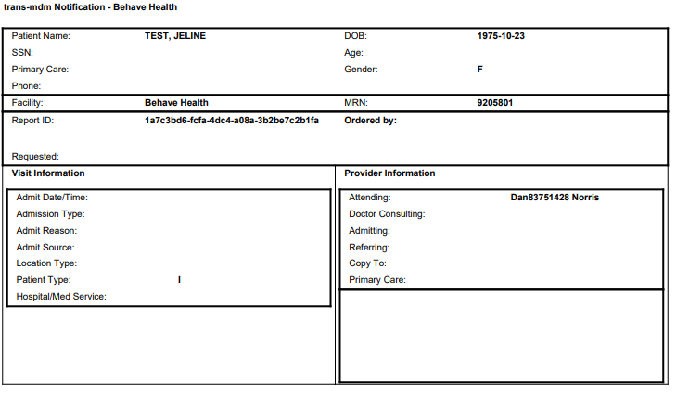
Figure 149. PDF Display of a trans-mdm Notification
Please Note: The data included in the report will depend on the type of message it is and what data is included by the sender.

3.7.2.3 Downloading Provider Results
The Provider Results Viewer also allows users to download the displayed record to their local system. This is accomplished by clicking the check box next to any of the displayed entries to select the messages the user wants to download, as shown in Figure 150. The user may click the check box in the main header to select all entries as described in the UI description in Section 3.2.1.2 .
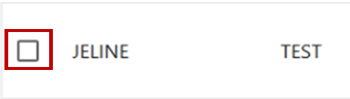
Figure 150. Selection Check Box for a Provider Result Entry
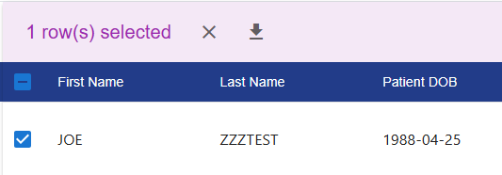
Once selected, a pink dialogue box will display at the top of the screen asking if the user would like to download the selected messages or cancel as shown in Figure 151. Clicking the download button  will download all selected messages to the specified location on the user’s local device.
Figure 151. Download Confirmation Prompt

4. Appendices

4.1 Appendix A - Allowing Third-Party Cookies
MIGateway® applications (including TOC Viewer) require third-party application cookies since the applications are embedded inside of Amazon Web Services (AWS). Browsers like Google Chrome and Mozilla Firefox have this allowed by default; Internet Explorer and Microsoft Edge may require third-party cookies to be allowed manually.
In most browsers, this setting can be found by going into Browser Settings, then Security and Privacy, and then Allow Third-Party Cookies.
In Microsoft Edge, if ‘do not allow third-party cookies' is selected and the setting is grayed out (disabled), use the following steps to allow the cookies:
- With an administrator account, click on the Windows search icon and type “gpedit.” Open the “Edit Group Policy” application.
- Navigate to the Microsoft Edge Cookie settings through the following path: Computer Configuration > Administrative Templates > Windows Components > Microsoft Edge > Configure Cookies.
- In the Configure Cookies window, select the “enable” radio button, and make sure “Allow All Cookies” is selected from the Configure Cookies drop-down.
- Click Apply and Okay. Close Edit Group Policy.
- This setting may need to be updated through the system using group policy. Open Command Prompt application.
- In Command Prompt, type “gpupdate /force.” Once this has successfully completed, you can close Command Prompt.

4.2 Appendix B - MIGateway® Applications with Cut-Off Drop-Down View
This occurs when a user is using Google Chrome (Version 68+) on Windows, MIGateway® application is open on an external monitor, and the display scaling setting of the computer’s monitors are different values (ex. 100% & 120%).
There is an open bug with the Chrome browser regarding dropdowns being cut off when display scaling sizes are different and the application loaded is in an Iframe (all MIGateway® applications are loaded in Iframes).
• https://bugs.chromium.org/p/chromium/issues/detail?id=877625
Steps to Troubleshoot:
Set the Scale and Layout setting to the same value for all displays.
- Open display settings by right clicking on the desktop and clicking Display Settings.
- All displays will appear numbered. For each display, do the following:
a. Under Scale and Layout, set the drop-down to the same value (ex. 100%).
- Refresh the MIGateway® web page and the dropdowns should not be cut off.

4.3 Appendix C - Service Communication
- MIGateway® Service Downtime: MiHIN will provide communication to MIGateway® users regarding service downtime.
  - An email notification will be sent to users for any downtime during normal business hours (8:00AM - 5:00PM Eastern Standard Time).
  - A follow-up email will be sent once MIGateway® services are available.
  - Users can sign up to receive these notifications by emailing help@mihin.org

4.4 Appendix D – Moving Away from Support of Internet Explorer (IE):
As of October 2019, Internet Explorer (IE) will no longer be a supported browser for MIGateway®. With the introduction of Microsoft Edge and the availability of more modern browsers (Mozilla Firefox, Google Chrome, etc.), more organizations are moving away from continuing to support IE integration with their applications.
MIGateway® will continue to support current and future versions of Firefox, Chrome, Edge, and for certain applicable modules, Safari.
For questions or concerns, please go to https://mihin.org/requesthelp/.

4.5 Appendix E – Wildcard Searches
Wildcard searches can be used in the First Name or Last Name MIGateway® filter fields within the Manage ACRS® or TOC Viewer modules to use partial spellings of names to find a wider array of results. The rules of wildcard searches are as follows:
- First Name + Date of Birth (DOB): First Name wildcard search must contain three (3) or more characters. E.g., ‘car’ + DOB.
- Last Name + Date of Birth (DOB): Last Name wildcard search must contain four (4) or more characters. E.g., ‘Fran’ + DOB.
- Searching BOTH First and Last Name + Date of Birth (DOB): Wildcard search will work if at least the First Name field has three (3) or more characters OR the Last Name field has four (4) or more characters.
  - E.g., First Name: ‘c’ and Last Name: ‘Fran’ + DOB.
  - E.g., First Name ‘car’ Last Name: ‘F’ + DOB
- Wildcard search will not work if one (1) or two (2) characters are specified for each field.
  - E.g., First Name ‘c’ and Last Name: ‘F’
  - First Name ‘ca’ and Last Name: ‘Fr’

4.6 Appendix F – Validation Email Examples
Validation | Status /Scenario | Description | Example Email Body
Individual File Validation | Attribution/Delivery Valid | Validation email received for valid attribution or delivery file submission. | Thank you for your recent submission of ACRS^{® (}2.0) Attribution(s). We received 1 file(s) and 1 passed successfully.  The following files were validated successfully. 3 of 3 rows were valid.
Individual File Validation | Attribution/Delivery Rows Invalid (via File Submission); Delivery Rows Invalid (via SFTP Submission) | Validation email received for invalid rows found in the attribution or delivery files during validation. | Thank you for your recent submission of ACRS® (2.0) Attribution(s). We received 1 file(s) and 0 validated successfully.  The following file(s) that you recently submitted failed validation. 12 of 15 rows were valid.
Individual File Validation | Attribution Rows Invalid (via SFTP Submission) | Validation email received for invalid rows found in the attribution file during validation when submission was received via SFTP Submission. | Thank you for your recent submission of ACRS® (2.0) Attribution(s). We received 1 file(s) and 0 validated successfully.  The following file(s) that you recently submitted failed validation. 2 of 6 rows were valid. If the attribution file submitted via SFTP is 50% or more cross valid, it will load.
Individual File Validation | Attribution/Delivery Format Invalid (via File Submission or SFTP Submission) | Validation email received if the attribution or delivery file failed validation due to formatting errors. | Thank you for your recent submission of ACRS® (2.0) Attribution(s). We received 1 file(s) and 0 validated successfully.  The following file(s) that you recently submitted failed validation. The file format was invalid.
Invalid File Type | Attribution or Delivery file contains header errors; or the wrong file type was submitted via SFTP | If the file submitted to File Submission via SFTP has an invalid header row; or the wrong type of file was submitted (ex. APS file) – it cannot get picked up for processing; and the submitter will receive an “Invalid File Type” notification via email | Dear Health Care Provider,  Thank you for your recent ACRS file submission via SFTP. We received your file but were unable to process it because it is not a valid ACRS attribution or delivery file.  File Details:
Cross File Validation | Cross Validation Success (via File Submission or SFTP Submission) | Cross-validation email received when an attribution and delivery file were submitted together and are found to have no cross-validation issues. | Thank you for your recent ACRS® (2.0) file submission. Cross validation passed successfully.  The following file(s) were submitted. 100% of the attribution file rows cross validated successfully. File(s) are now being loaded.
Cross File Validation | Cross Validation Skipped (via File Submission) | Cross-validation email received when either the attribution or delivery files are submitted independently and the file submitted was valid and is being loaded. | Thank you for your recent ACRS® (2.0) file submission. Cross validation was skipped because only one file was uploaded.  The following file(s) were submitted. File(s) are now being loaded.
Cross File Validation | Cross Validation Skipped (via File Submission) | Cross-validation email received when either the attribution or delivery files are submitted independently, and the file submitted was invalid and did not load automatically after validation. | Thank you for your recent ACRS® (2.0) file submission. Cross validation was skipped because only one file was uploaded.  The following file(s) were submitted. File(s) were not loaded because the Attribution or Delivery file was invalid.
Cross File Validation | Cross Validation Skipped (via SFTP Submission) | Cross-validation email received when attribution and delivery files are submitted together, and either delivery or attribution files have errors. | Thank you for your recent ACRS® (2.0) file submission. Cross validation was skipped because the attribution file was invalid.  The following file(s) were submitted. File(s) were not loaded because the Attribution or Delivery file was invalid.
Cross File Validation | Cross Validation Failed (via SFTP Submission) | Cross-validation email received when attribution and delivery files are submitted together and there are cross-validation errors found. | Thank you for your recent ACRS® (2.0) file submission. Cross validation failed.  The following file(s) that you recently submitted failed cross validation. 33% of the attribution file rows cross validated successfully. The file(s) were not loaded.
Cross File Validation | Cross Validation Failed (via SFTP Submission) | Cross-validation email received when attribution and delivery files are submitted together and there are cross-validation errors found.  *Does not mean that the SFTP Submission did not load; that would depend on the percentage of cross-validated rows successfully, as indicated in the email. | Thank you for your recent ACRS® (2.0) file submission. Cross validation failed.  The following file(s) that you recently submitted failed cross validation. 66% of the attribution file rows cross validated successfully. At least 50% of valid attribution rows must cross validate successfully for files to load via SFTP.
Partial Upload | Partial Upload Triggered | Email received when validation or cross-validation errors are found, and the errors are accepted, and the submission is loaded anyway.  *Note: only invalid rows from the attribution or delivery file are removed during partial upload. Rows with cross-validation errors are not removed from loading to ACRS. | Thank you for your recent ACRS® (2.0) file submission.  Please note: upon initial validation, some rows in the file were marked as invalid.  The end user opted to delete those rows and proceed with loading only the valid rows.  The valid rows from the following files were submitted and are now being loaded.
Loaded | Attribution and/or Delivery File loaded successfully (via File Submission or SFTP Submission) | Email received to notify the submitter of the attribution/delivery file(s) successfully loading. | Thank you for your recent ACRS® (2.0) file submission. All files loaded successfully.

4.7 Appendix G – C-CDA Documents

C-CDA Templates
US Realm CDA Header | Diagnostic Imaging Report (DIR) V2 | Patient Questionnaire Summary Document
US Realm Header (V2) | Procedure Note | MDS Patient Questionnaire Summary Document
Continuity of Care Document | Procedure Note V2 | OASIS Patient Questionnaire Summary Document
Continuity of Care Document V2 | Operative Note | Transfer Summary Document (MASS HIE)
History and Physical | Operative Note V2 | Transfer Summary (C-CDA)
History and Physical V2 | Discharge Summary | Referral Summary (C-CDA)
Consultation Note | Discharge Summary V2 | Care Plan (C-CDA)
Consultation Note V2 | Progress Note | Care Plan (Nutrition)
Diagnostic Imaging Report (DIR) | Progress Note V2 | Minimally Structured Document (Xdoc)
Unstructured Document (V2) | Unstructured Document

4.8 Appendix H – Expiration Notice Email
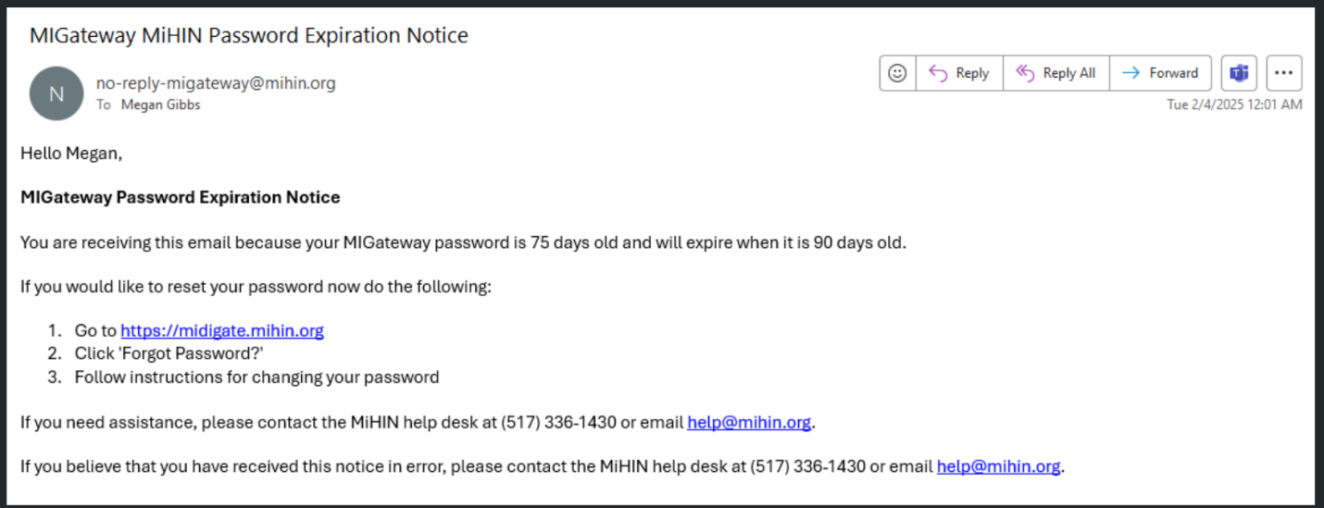
Figure 152. Expiration Notice Email Example

4.9 Appendix I – Troubleshooting Optional Fields when Adding a new Patient/Relationship
Providers and Practices
- If you do not see any Providers or Practices available in the filter or dropdown menus, please wait for the full list to load before attempting any further actions. These are large lists and may have a slight delay when loading.
- If you’ve waited and still do not see any Providers or Practices or if you receive a “Providers in ACRS File cannot be found….” error message at the top of the page, try refreshing and wait again.
- If after refreshing and waiting they still do not populate and they are not needed for your intended activity, please proceed without this. If they are needed, please email help@mihin.org or submit a Help Desk ticket

5. Production Support
 | Severity Levels
 | 1 | 2 | 3 | 4
Description | A critical production system is down or does not function at all, and there is no circumvention or workaround for the problem; a significant number of users are affected, and a production business system is inoperable. | More than 90% of messages received and delivered successfully, but some messages are not delivered/received with required accuracy. Service component severely restricted in one of the following ways:  - High impact risk or actual occurrence of patient care affected or operational impairment  - Business critical service has a partial failure for multiple TDSOs  - A critical service is online however, is operating in a degregated state and having a significant impact on multiple TDSOs | Service component restricted in one of the following ways:  - A component is not performing as documented or there are unexpected results  - Business critical service has failed for a two or more TDSOs  - A critical service is usable however, a workaround is available or less significant features are unavailable  . | No operational impact to MiHIN. A non-critical service component is malfunctioning, causing minimal impact, or a test system is down.
Initiation Method | Call (844) 454-2443 and submit a ticket online at www.mihin.org/requesthelp | Call (844) 454-2443 and submit a ticket online at www.mihin.org/requesthelp | Submit a ticket online at www.mihin.org/requesthelp | Submit a ticket online at www.mihin.org/requesthelp
Initial Response | Within 30 minutes | Within 30 minutes | Within 3 business hours | Within 6 business hours
Resolution Goal | <2 hours Restore Time from 7 am – 6 pm EST Monday-Friday and <4 hours nights, weekends and holidays | <4 hours Restore Time from 7 am- 6 pm EST Monday-Friday and <8 hours nights, weekends and holidays | <12 hours Restore Time from 7 am -6 pm EST Monday –Friday and <24 hours nights, weekends and holidays. | Within 5 business days
A list of frequent questions regarding the MIGateway® application can be found at:
https://mihin.org/migateway/. If you have questions, please contact the MiHIN Help Desk:
- www.mihin.org/requesthelp
- help@mihin.org
- Phone: 844-454-2443
- Monday – Friday 8:00 AM – 5:00 PM EST

6. Acronyms and Abbreviations Guide

ACK | HL7 Acknowledgment message
ACRS® | Active Care Relationship Service
API | Application Programming Interface
CCHD | Critical Congenital Heart Disease
CMS | Centers for Medicare & Medicaid Services
DDE | Direct Data Entry
DQA | Data Quality Assurance
EHR | Electronic Health Record
FHIR | Fast Healthcare Interoperability Resources
HIE | Health Information Exchange
HIN | Health Information Network
HISP | Health Internet Service Provider
HL7 | Health Level Seven
HPD | Health Provider Directory
MDHHS | Michigan Department of Health and Human Services
MIGateway® | Medical Information Direct Gateway
MiHIN | Michigan Health Information Network Shared Services
MUCA | Master Use Case Agreement
NACK | Negative Acknowledgement
NBS | Newborn Screening
NwHIN | Nationwide Health Information Network
OID | Object Identifier
PO | Participating Organization
RAS | Registration and Attestation System
REST | Representational State Transfer
SAML | Security Assertion Markup Language
SMTP | Simple Mail Transfer Protocol
SOM | State of Michigan
TDSO | Trusted Data Sharing Organization
UCE | Use Case Exhibit
UCS | Use Case Summary
VPN | Virtual Private Network
XCA | Cross-Community Access
XDS | Cross-Enterprise Document Sharing

7. Definitions
Active Care Relationship (ACR). An ACR may be any of the following:
- For health providers: a patient who has been seen by a provider within the past 24 months or is considered part of the health provider’s active patient population they are responsible for managing, unless notice of termination of that treatment relationship has been provided to MiHIN
- For payers: an eligible member of a health plan
- An active relationship between a patient and a health provider for the purpose of treatment, payment, and/or healthcare operations consistent with the requirements set forth in HIPAA.
- A relationship with a health provider asserted by a consumer and approved by the health provider.
- (e) Any person or Trusted Data Sharing Organization (TDSO) authorized to receive message content under an exhibit which specifies that an ACR may be generated by sending or receiving message content under that exhibit
ACR records are stored by MiHIN in the Active Care Relationship Service® (ACRS®).
Active Care Relationship Service® (ACRS®). ACRS® is MiHIN’s care mapping service supporting the ability to exchange real-time notifications and updates on a patient to all of those in the health ecosystem legally caring for that person. ACRS® creates an electronic roadmap between care team members so any changes to a patient’s status can be sent to the relevant providers, even if they are part of different organizations or medical groups and work on different systems.
Admission, Discharge, Transfer (ADT). An event that occurs when a patient is admitted to, discharged from, or transferred from one care setting to another care setting or to the patient’s home. For example, an ADT event occurs when a patient is discharged from a hospital. An ADT event also occurs when a patient arrives in a care setting such as a health clinic or hospital.
Applicable Laws and Standards. In addition to the definition set forth in the Data Sharing Agreement, the federal Confidentiality of Alcohol and Drug Abuse Patient Records statute, section 543 of the Public Health Service Act, 42 U.S.C. 290dd-2, and its implementing regulation, 42 CFR Part 2; the Michigan Mental Health Code, at MCLA §§ 333.1748 and 333.1748a; and the Michigan Public Health Code, at MCL § 333.5131, 5114a.
Attribution. The connection between a consumer and their health care providers. One definition of attribution is “assigning a provider or providers who will be held accountable for a member based on an analysis of that member’s claim data.” The attributed provider is deemed responsible for the patient’s cost and quality of care, regardless of which providers deliver the service.
Conforming Message. A message that is in a standard format that strictly adheres to the implementation guide for its applicable use case.
Critical Congenital Heart Disease (CCHD). A group of serious heart defects that are present from birth. These abnormalities result from problems with the formation of one or more parts of the heart during the initial stages of embryonic development.
Data Sharing Agreement. Any data sharing organization agreement signed by both MiHIN and a participating organization. Data sharing organization agreements include but are not limited to: Qualified Data Sharing Organization Agreement, Virtual Qualified Data Sharing Organization Agreement, Consumer Qualified Data Sharing Agreement, Sponsored Shared Organization Agreement, State Sponsored Sharing Organization Agreement, Direct Data Sharing Organization Agreement, Simple Data Sharing Organization Agreement, or other data sharing organization agreements developed by MiHIN.
Electronic Address. A string that identifies the transport protocol and end point address for communicating electronically with a recipient. A recipient may be a person, organization, or other entity that has designated the electronic address as the point at which it will receive electronic messages. Examples of an electronic address include a secure email address (Direct via secure SMTP) or secure URL (SOAP / XDR / REST / FHIR). Communication with an electronic address may require a digital certificate or participation in a trust bundle.
Electronic Medical Record or Electronic Health Record (EMR/EHR). A digital version of a patient's paper medical chart.
Electronic Service Information (ESI). All information necessary to define an electronic destination’s ability to receive and use a specific type of information (e.g., discharge summary, patient summary, laboratory report, or query for patient/provider/healthcare data). ESI may include the type of information (e.g. patient summary or query), the destination’s electronic address, the messaging framework supported (e.g., SMTP, HTTP/SOAP, XDR, REST, FHIR), security information supported or required (e.g., digital certificate), and specific payload definitions (e.g., CCD C32 V2.5). In addition, ESI may include labels that help identify the type of recipient (e.g., medical records department).
End Point. An instance of an electronic address or ESI.
Exhibit. Collectively, a use case exhibit or a pilot activity exhibit.
FedSim. Simulators that are utilized in a testing environment to simulate testing with a federal partner (e.g., Social Security Administration or Veterans Affairs)
Health Directory. The statewide shared service established by MiHIN that contains contact information on health providers, electronic addresses, end points, and ESI as a resource for authorized users to obtain contact information and to securely exchange health information.
Health Level 7 (HL7). An interface standard and specifications for clinical and administrative healthcare data developed by the Health Level Seven organization and approved by the American National Standards Institute (ANSI). HL7 provides a method for disparate systems to communicate clinical and administrative information in a normalized format with acknowledgement of receipt.
Health Information. Any information, including genetic information, whether oral or recorded in any form or medium, that (a) is created or received by a health provider, public health authority, employer, life insurer, school or university, or healthcare clearinghouse; and (b) relates to the past, present, or future physical or mental health or condition of an individual; the provision of health care to an individual; or the past, present, or future payment for the provision of health care to an individual.
Health Information Network (HIN). An organization or group of organizations responsible for coordinating the exchange of protected health information (PHI) in a region, state, or nationally.
Health Plan. An individual or group plan that provides or pays the cost of medical care (as “group health plan” and “medical care” are defined in section 2791(a)(2) of the Public Health Service Act, 42 U.S.C. 300gg-91(a)(2)). Health plans further include those entities defined as a health plan under HIPAA, 45 C.F.R 160.103.
Health Professional.(a) any individual licensed, registered, or certified under applicable federal or state laws or regulations to provide healthcare services; (b) any person holding a nonclinical position within or associated with an organization that provides or coordinates healthcare or healthcare-related services; and (c) people who contribute to the gathering, recording, processing, analysis, or communication of health information. Examples include, but are not limited to, physicians, physician assistants, nurse practitioners, nurses, medical assistants, home health professionals, administrative assistants, care managers, care coordinators, receptionists, and clerks.
Health Provider. Facilities/hospitals, health professionals, health plans, caregivers, pharmacists/other qualified professionals, or any other person or organization involved in providing healthcare.
Information Source. Any organization that provides information that is added to a MiHIN infrastructure service.
Master Use Case Agreement (MUCA). Legal document covering expected rules of engagement across all use cases. Trusted data sharing organizations sign the master use case agreement once, then sign use case exhibits for participation in specific use cases.
Message. A mechanism for exchanging message content between the participating organization to MiHIN services, including query and retrieve.
Message Content. Information, as further defined in an exhibit, which is sent, received, found, or used by a participating organization to or from MiHIN services. Message content includes the message content header.
Message Header (“MSH”) or Message Content Header. The MSH segment present in every HL7 message type defines the message’s source, purpose, destination, and specific syntax such as delimiters (separator characters) and character sets. It is always the first segment in the HL7 message, with the only exception being HL7 batch messages.
Michigan Health Information Network Shared Services. The state-designated HIE, serving as a consolidated, statewide, public-private partnership.
Medical
MiHIN Infrastructure Service. Certain services that are shared by numerous use cases. MiHIN infrastructure services include, but are not limited to, Active Care Relationship Service (ACRS®), Health Directory, Statewide Consumer Directory (SCD), and the Medical Information Direct Gateway (MIGateway®).
MiHIN Services. The MiHIN infrastructure services and additional services and functionality provided by MiHIN allowing the participating organizations to send, receive, find, or use information to or from MiHIN as further set forth in an exhibit.
Negative Acknowledgment (NAK or NACK). “Not acknowledged” and is used to negatively acknowledge or to reject previously received message content or to indicate an error.
Newborn Screening. Screening to detect
conditions such as critical congenital heart disease (CCHD) in newborns. The newborn screening is not limited to this test.
Notice. A message transmission that is not message content and which may include an acknowledgement of receipt or error response, such as an ACK or NACK.
Patient Data. Any data about a patient or a consumer that is electronically filed in a participating organization’s systems or repositories. The data may contain protected health information (PHI), personal credit information (PCI), and/or personally identifiable information (PII).
Person Record. Any record in a MiHIN infrastructure service that primarily relates to a person.
Pilot Activity. The activities set forth in the applicable exhibit, which typically include sharing message content through early trials of a use case that is still being defined and is still under development. A pilot activity may include participating organization feedback to MiHIN to assist in finalizing a use case exhibit upon conclusion of the pilot activity.
Principal. A person or a system utilizing a federated identity through a federated organization.
Promoting Interoperability. Using certified EHR technology to improve quality, safety, and efficiency of healthcare, and to reduce health disparities as further contemplated by title XIII of the American Recovery and Reinvestment Act of 2009.
Provider Community. A healthcare provider with an active care relationship with the applicable patient.
Send / Receive / Find / Use (SRFU). It means sending, receiving, finding, or using message content. Sending involves the transport of message content. Receiving involves accepting and consuming or storing message content. Finding means querying to locate message content. Using means any use of the message content other than sending, receiving, and finding. Examples of use include consuming into workflow, reporting, storing, or analysis. Send/Receive/Find/Use (SRFU) activities must comply with Applicable Laws & Standards or State Administrative Code as that term is defined in the data sharing agreement.
Service Interruption. A party is unable to send, receive, or find message content for any reason, including the failure of network equipment or software, scheduled or unscheduled maintenance, general Internet outages, and events of force.
Source System. A computer system, such as an electronic health record system, at the participating organization that sends, receives, finds, or uses message content or notices.
Transactional Basis. The transmission of message content or a notice within a period of receiving message content or notice from a sending or receiving party may be further set forth in a specific exhibit.
Transitions of Care. The movement of a patient from one setting of care (e.g., hospital, ambulatory primary care practice, ambulatory specialty care practice, long-term care, rehabilitation facility, etc.) to another setting of care and can include transfers within a healthcare organization.
Trusted Data Sharing Organization (TDSO). An organization that has signed any form of agreement with MiHIN for data sharing.
Use Case. (a) A use case agreement previously executed by a participating organization; or (b) the use case summary, use case exhibit, and a use case implementation guide that participating organization or TDSO must follow to share specific message content with the MiHIN.
Use Case Exhibit. The legal agreement attached as an exhibit to the master use case agreement that governs participation in any specific use case.
Use Case Implementation Guide (UCIG). The document providing technical specifications related to message content and transport of message content between a participating organization, MiHIN, and other TDSOs. Use case implementation guides are made available via URLs in exhibits.
Use Case Summary. The document providing the executive summary, business justification, and value proposition of a use case. Use case summaries are provided by MiHIN upon request and via the MiHIN website at www.mihin.org.
View Download Transmit (VDT). A requirement for Meaningful Use with the objective of providing patients with the ability to view online, download, and transmit their health information within a certain period of the information being available to an eligible professional.
XCA. The IHE (Integrating the Healthcare Enterprise®) standard for Cross-Community Access which provides specifications to query and retrieve patient-relevant health information held by other communities.
XDS.b. The IHE (Integrating the Healthcare Enterprise®) standard for Cross-Enterprise Document Sharing Revision B, which provides specifications to query and retrieve patient-relevant healthcare data held within a community.

